Brüggemann at K2019:
Upcycling from polyamide waste to high quality injection molding grades
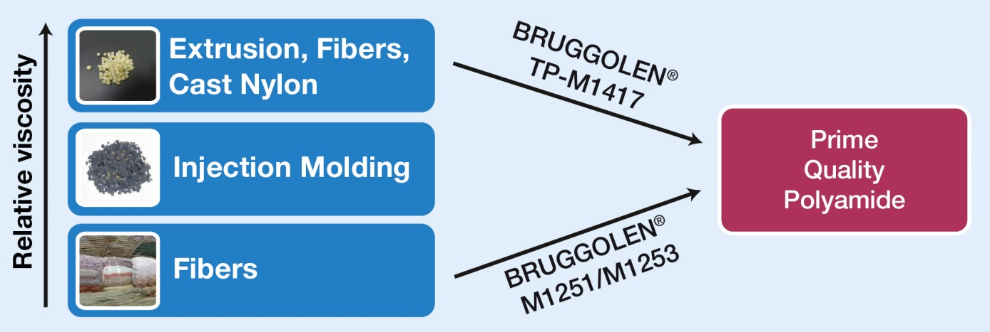
BRUGGOLEN® TP-M1417 and BRUGGOLEN® M1251/1253 allow precise and reproducible adjustment of the relative viscosities of PA waste to the level of high-quality injection molding grades. © Brüggemann
Heilbronn and Dusseldorf, Germany, October 16, 2019 – When recycling polyamides, Brüggemann's BRUGGOLEN® M series of reactive chain modifiers allow precise and reproducible adjustment of relative viscosities, by either lengthening excessively short chains or shortening those which are too long. Producers can use small amounts of these modifiers to tailor relative viscosities to their needs in a single compounding step. The resultant upcycled materials exhibit excellent mechanical properties and are suitable for the same applications as prime materials of similar viscosities. This removes the need to blend the recyclate with prime polymers and opens up a wide range of possibilities for establishing a profitable market for secondary polyamide raw materials which meet the high-quality requirements of the molding industry.
BRUGGOLEN® TP-M1417 provides a precise and robust way of shortening the excessively long molecular chains of high viscosity polyamide waste found in materials such as high viscosity extrudates, films or cast nylon. Addition of just a small quantity of the additive during a single extrusion step is able to decrease the viscosity so that the polymer can be injection molded. The final viscosity can be very accurately controlled by adjusting the quantity added. Significantly, the mechanical properties of moldings from the resultant polymer are similar to those achieved by prime polyamides.
Using BRUGGOLEN® M1251 makes it possible to compensate, by linear chain extension, for the reduction in molecular weight arising from the degradation caused by processing and previous use. As a result, the mechanical properties of the recyclate can be improved to match those of prime material. BRUGGOLEN® M1253, available as a smaller pellet size of the same additive, makes for easier dosing during compounding.
Both modifiers are supplied as dust free polymeric granules suitable for accurate metering. They are easy to process and to disperse in the polyamide matrix.
As an established manufacturer of high-performance additives for polyamides, Brüggemann offers a broad portfolio for recycling these polymers which goes beyond reactive chain modifiers of the BRUGGOLEN® M series. The range covers long-term heat stabilizers, processing stabilizers, flow enhancers, nucleating agents and other auxiliaries. Upcycling for high-quality applications necessitates a targeted selection and combination of these additives.
L. Brüggemann GmbH & Co. KG is a renowned manufacturer of specialty chemicals with some 200 staff. Founded in 1868, the company, headquartered in Heilbronn/Germany, specializes in developing and manufacturing of high-performance additives for engineering thermoplastics with a focus on polyamides, as well as zinc derivatives and sulfur-based reducing agents. Customers from more than 60 countries have come to value the company's flexibility and innovative product solutions, while subsidiaries in the USA and Hong Kong emphasize its international outlook. The cornerstones of corporate policy are in-house research and development activities, a consistent focus on customer requirements, and major investment in know-how and plant.

Further information:
Dr. Klaus Bergmann, Business Unit Manager Polymer Additives
L. Brüggemann GmbH & Co. KG, Salzstraße 131, 74076 Heilbronn, Germany
Phone: +49 (0) 71 31 / 15 75 – 235, Email: klaus.bergmann@brueggemann.com

Editorial contact and please send voucher copies to:
Dr.-Ing. Jörg Wolters, Konsens PR GmbH & Co. KG,
Hans-Kudlich-Straße 25, 64823 Groß-Umstadt, Germany – www.konsens.de
Phone: +49 (0) 60 78 / 93 63 - 0, Email: joerg.wolters@konsens.de
Press releases from Brüggemann including text and pictures in printable resolution can be downloaded from: www.konsens.de/brueggemann.html

