Phenolic Plus BRUGGOLEN® TP-H1803 bridges the price-performance gap in polyamide heat stabilization
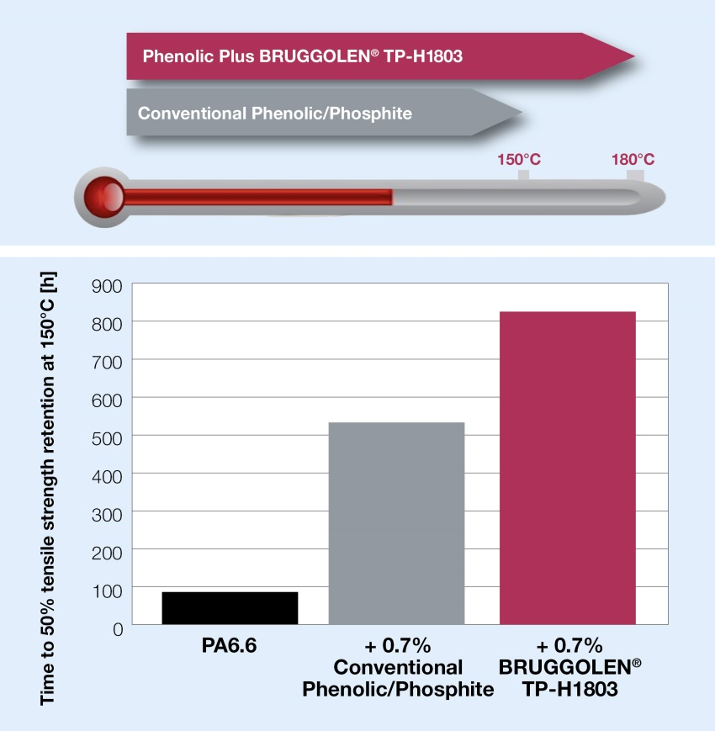 | Compared to commercially available blends of sterically hindered phenols and phosphites, Phenolic Plus BRUGGOLEN® TP-H1803 extends the stabilization of polyamides at a similar cost in use.  © Brüggemann
Heilbronn/Germany, May 2020 – Brüggemann's Phenolic Plus BRUGGOLEN® TP-H1803 is a new heat stabilizer for polyamides designed to outperform conventional phenolic/phosphite based stabilizers, i.e. blends of sterically hindered phenolic antioxidants with organic phosphites. BRUGGOLEN® TP-H1803 bridges the price-performance gap between these blends and copper based stabilizers.
Phenolic Plus extends the heat stabilization of polyamides to peak temperatures of 180°C, something not possible for hindered phenolic antioxidants and organic phosphites. Furthermore, due to the high efficiency of Phenolic Plus, lower dosages are possible than those needed by conventional phenolic/phosphite blends in order to achieve the same effect. For example, in trials at 150°C, the dosage of Phenolic Plus BRUGGOLEN® TP-H1803 could be reduced by 30% compared to that of a standard stabilizer package, whilst still maintaining the same level of tensile strength retention after heat aging.
Brüggemann supplies BRUGGOLEN® TP-H1803 in the form of dust-free pellets which can be easily metered and readily dispersed and are suitable for both compounding and injection molding.
L. Brüggemann GmbH & Co. KG is a renowned manufacturer of specialty chemicals with some 200 staff. Founded in 1868, the company, headquartered in Heilbronn/Germany, specializes in developing and manufacturing of high-performance additives for engineering thermoplastics with a focus on polyamides, as well as zinc derivatives and sulfur-based reducing agents. Customers from more than 60 countries have come to value the company's flexibility and innovative product solutions, while subsidiaries in the USA and Hong Kong emphasize its international outlook. The cornerstones of corporate policy are in-house research and development activities, a consistent focus on customer requirements, and major investment in know-how and plant.

Further information:
Dr. Klaus Bergmann, Business Unit Manager Polymer Additives
L. Brüggemann GmbH & Co. KG, Salzstraße 131, 74076 Heilbronn, Germany
Phone: +49 (0) 71 31 / 15 75 – 235, Email: klaus.bergmann@brueggemann.com

Editorial contact and voucher copies:
Dr.-Ing. Jörg Wolters, Konsens PR GmbH & Co. KG,
Im Kühlen Grund 10, 64823 Groß-Umstadt, Germany – www.konsens.de
Phone: +49 (0) 60 78 / 93 63 - 0, Email: joerg.wolters@konsens.de
Press releases from BrüggemannChemical including text and pictures in printable resolution can be downloaded from: https://www.konsens.de/brueggemann

