Brüggemann at K2019:
For virgin polyamides and polyamide recyclates:
New BRUGGOLEN® additives overcome performance boundaries
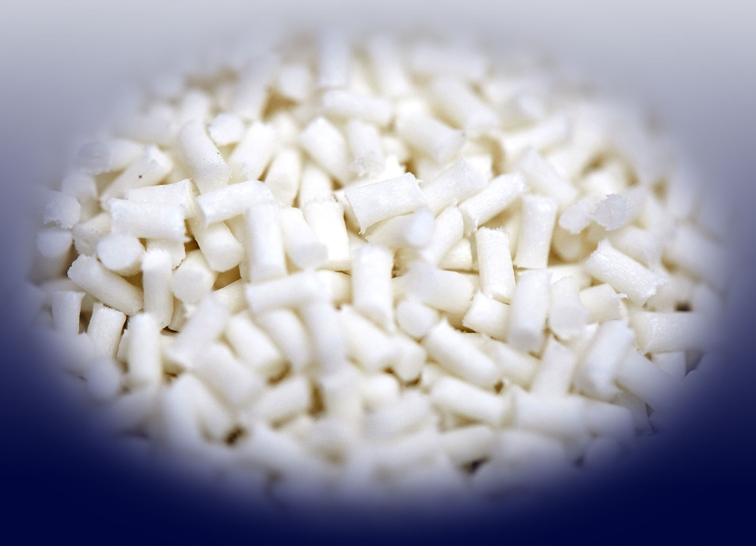
Newly developed additives from Brüggemann give polyamide compounders and processors the possibility to produce materials that exceed previous performance limits. © Brüggemann.
Heilbronn/Germany, August 2019 – At K 2019, Brüggemann (www.brueggemann.com) will present its latest developments in performance-enhancing, cost-effective additives for both virgin polyamides and polyamide recyclates. The innovations range from efficiency-increasing flow enhancers for shorter cycle times and thinner wall thicknesses, through new heat stabilizers for medium to very high temperatures, to reactive additives for the production of recyclates which match the quality of virgin materials.
Flow enhancers now available for all polyamides
BRUGGOLEN® TP-P1810 allows for the first time a significant improvement in flow properties of polyphthalamides (PPA, such as PA6T, PA6T/6I, PA6T/6.6 etc.) while retaining overall mechanical property characteristics. Compounders and injection molders can thus significantly widen the processing window and combine high cost efficiency with application-specific optimization. For example, it is possible with BRUGGOLEN® TP-P1810 to reliably produce and easily process compounds with very high fiber contents (e.g. 60 %). Together with BRUGGOLEN® TP-P1507 for aliphatic polyamides (such as PA6, PA6.6, PA12 etc.), which was first introduced at K 2016, Brüggemann offers flow enhancers for all polyamide types. Producers and processors of the corresponding compounds will benefit from much shorter cycle times. Furthermore, both flow enhancers allow the production of large or complex parts with long flow paths and/or low wall thicknesses.
Heat stabilizers for the entire temperature range – all from one source
Brüggemann underlines its recognized development expertise and its ability to offer solutions for all stabilization tasks by bolstering its already extensive existing product range with exciting and unique antioxidants which are launched at K 2019.
- Phenolic Plus BRUGGOLEN® TP-H1803 fills the price and performance gap between existing phenolic-based and copper-based stabilizer blends. It improves long-term heat aging stabilization compared to conventional phenolic systems, extending the temperature range to reach peaks of 180 °C, something not possible with standard phenolics.
- In cases where long-term resistance at elevated temperatures up to 180 °C is a priority, Brüggemann offers BRUGGOLEN® TP-H1607, a new high-performance and cost-effective copper iodide-based stabilizer. Based on proprietary technology, its effectiveness significantly exceeds that of the traditional copper iodide/potassium iodide stabilizers without making any compromises in terms of material properties. As a result, the required thermal protection is reached with very low concentrations – a particular advantage in E+E applications.
- With the new BRUGGOLEN® TP-H1805, Brüggemann offers the opportunity to stabilize fiber-reinforced aliphatic polyamides for long-term use at temperatures up to 200 °C for PA 6 or up to 230 °C for PA 6.6. This enables compounders to tailor-make products for applications in borderline areas that were until now the preserve of polyphthalamides or other high-performance polymers such as PPS. Injection-molded parts produced with this additive – for example air ducts and pipes in the engine compartment – offer excellent heat resistance over the entire required temperature range. Separate activation is not needed.
For optimized recyclates with the properties of virgin materials
As an established manufacturer of high-performance additives for polyamides, Brüggemann offers a broad portfolio for the recycling of these polymers. The range covers long-term heat agents, processing stabilizers, flow enhancers, reactive chain modifiers, nucleating agents and other functional auxiliaries. Upcycling for high-quality applications necessitates the targeted selection and combination of these additives. Especially important are reactive chain modifiers that enable molecular weight and viscosity to be precisely adjusted to suit the needs of any particular application.
- BRUGGOLEN® M1251 compensates, through linear chain lengthening, any decline in molecular weight during previous processing, and thus improves the mechanical properties of the recyclate to match those of virgin material. BRUGGOLEN® M1253, available as a smaller pellet size of the same additive, makes for easier dosage during compounding.
- BRUGGOLEN® TP-M1417 specifically shortens excessively long molecular chains of high-viscosity polyamide scrap, e.g. from extrudate, fibers or cast polyamides. Only small quantities and a single extrusion step are sufficient to produce high-grade recyclate that is optimally suited for injection molding and with performance properties that match those of virgin material.
These chain modifiers are particularly effective in enabling secondary PA material to meet high quality specifications and, as a result, help to meet the need for increasing recycling quotas.
L. Brüggemann GmbH & Co. KG is a renowned manufacturer of specialty chemicals with some 200 staff. Founded in 1868, the company, headquartered in Heilbronn/Germany, specializes in developing and manufacturing of high-performance additives for engineering thermoplastics with a focus on polyamides, as well as zinc derivatives and sulfur-based reducing agents. Customers from more than 60 countries have come to value the company's flexibility and innovative product solutions, while subsidiaries in the USA and Hong Kong emphasize its international outlook. The cornerstones of corporate policy are in-house research and development activities, a consistent focus on customer requirements, and major investment in know-how and plant.

Further information:
Dr. Klaus Bergmann, Business Unit Manager Polymer Additives
L. Brüggemann GmbH & Co. KG, Salzstraße 131, 74076 Heilbronn, Germany
Phone: +49 (0) 71 31 / 15 75 – 235, Email: klaus.bergmann@brueggemann.com

Editorial contact and voucher copies:
Dr.-Ing. Jörg Wolters, Konsens PR GmbH & Co. KG,
Hans-Kudlich-Straße 25, 64823 Groß-Umstadt, Germany – www.konsens.de
Phone: +49 (0) 60 78 / 93 63 - 0, Email: joerg.wolters@konsens.de
Press releases from BrüggemannChemical including text and pictures in printable resolution can be downloaded from: www.konsens.de/brueggemann.html

