Press RELEASE

Asaf Eylon appointed General Manager of Tosaf’s Additives, Whites and Compounds Division

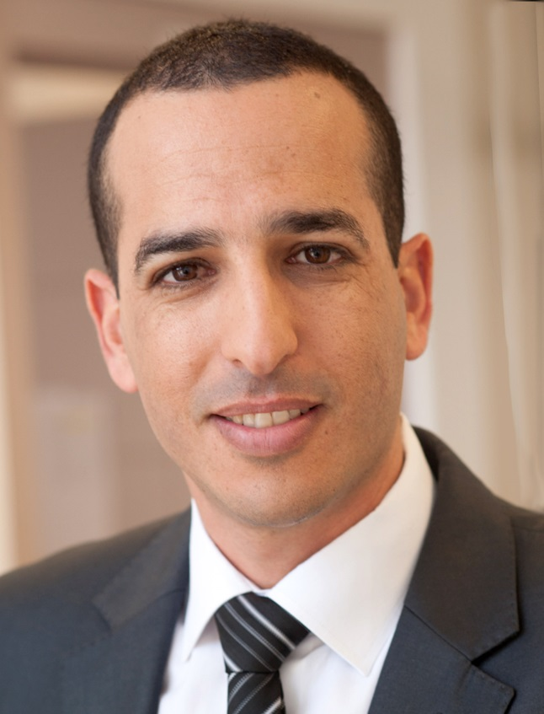
Asaf Eylon, newly appointed General Manager of Tosaf's Additives, Whites and Compounds activities
Afula/Israel, March 2016 –– Tosaf (www.tosaf.com) has appointed Asaf Eylon, 41, as new General Manager of the company’s Additives, Whites & Compounds activities. Eylon started his career at Tosaf in 2005, holding various sales positions within the company, managing the colour masterbatch plants in Turkey and Belgium and until recently serving as Vice President International Sales & Marketing.
“This is an exciting challenge which I am very much looking forward to”, says Eylon. “Tosaf’s prominent position in the plastics industry with global market presence, a professional team and state-of-the-art equipment provide an excellent basis to take the company to new heights.”
And Amos Megides, Tosaf Chairman of the Board, adds: “Asaf Eylon has gained extensive experience in the plastics industry while working in various high profile businesses where product and service quality are crucial. We are convinced that he will go on to develop and maintain these high standards in his new position at Tosaf, and we wish him all the best in his new position.”
Tosaf Group, founded in 1985, is a joint-venture between Megides Holding and the Ravago Group. The group operates ten factories in Israel, Turkey, Germany, UK, The Netherlands and China, with a total of 900 employees. Tosaf’s versatile range of products includes mineral-filled compounds for the white goods industry, automotive and other plastic industries, additives such as UV/light stabilisers, anti-fog, flame retardant and customised additives for applications including BOPP, agricultural, packaging and industrial films, polycarbonate sheets, pipes, foams and other products, as well as colour masterbatches for a wide range of applications.
For further information about Tosaf please contact:
Ms. Keren Leffler
International Marketing, Tosaf Compounds Ltd.
Phone: +972-9-8984606, Fax: +972-9-8789-723
Email: kerenl@tosaf.com
Editorial contact, and please send voucher copies to:
KONSENS PR GmbH & Co. KG
Dr. Jörg Wolters
Hans-Kudlich-Str. 25, D-64823 Groß-Umstadt,
Phone: +49 (0) 60 78/93 63-13, Fax: +49 (0) 60 78/93 63-20
Email: mail@konsens.de

Dear editors,
for your convenience please download image and text of this press release from: http://www.konsens.de/tosaf.html

