Press RELEASE

New antistatic masterbatch for PP provides excellent efficiency at very low atmospheric humidity

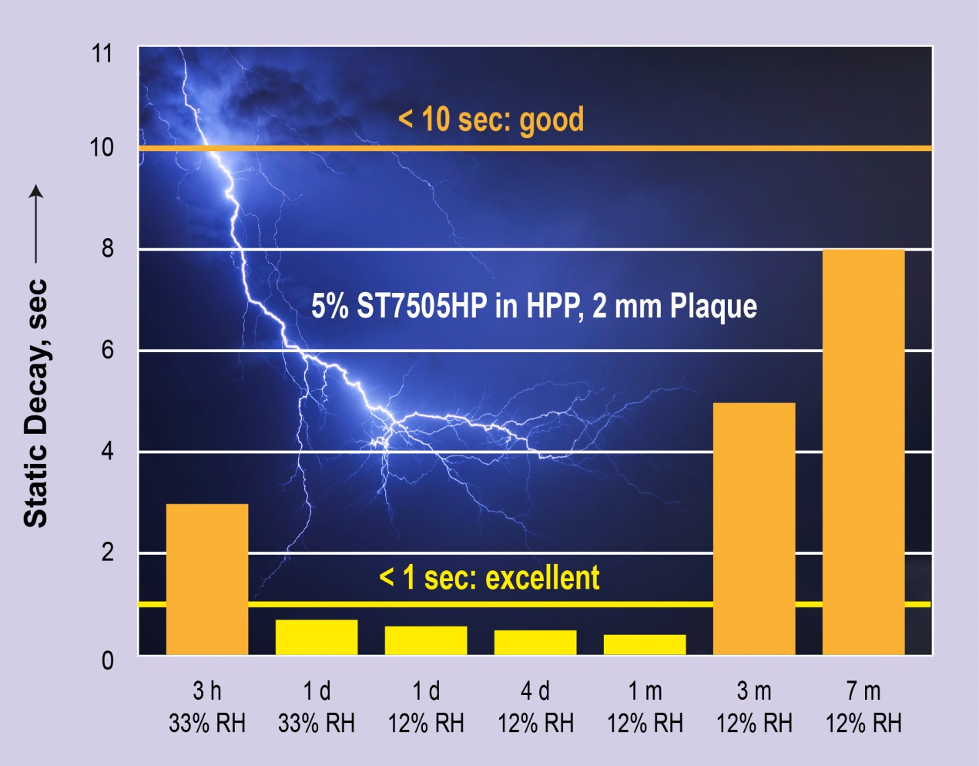
Even small quantities of 5% and below of Tosaf's new masterbatch ST7505HP provide an “excellent” antistatic effect* (decay time < 1 sec) in very dry air, still remaining “good” (decay time < 10 sec) after 3 months and beyond.
*static decay meter according to NFPA 99 - 10% cutoff, 90% dissipation, from 5 kV to 0.5 kV.
Afula/Israel, December 2015 –– ST7505HP is a newly developed antistatic masterbatch from Tosaf (www.tosaf.com), which is optimised for polypropylene (PP) and remains highly effective even at very low atmospheric humidity. Already low rates of addition of just 1% to 5% for extrusion and 3% to 5% for injection moulding bring about a significant reduction of the high electrical surface resistance, which is typical for products made of PP. As a result, electrical charges can decay very quickly from moulded parts, rigid packaging or films even in regions with a dry climate or on dry winter days. ST7505HP has no effect on the colour and transparency of the material and meets FDA and EU requirements for food contact.
In laboratory testing, ST7505HP has demonstrated its excellent antistatic effect which is retained over the long term even at just 12% RH (see graph), whereas conventional additives of this kind, such as hydrophilic surfactants, require a significantly higher atmospheric humidity in order to be effective. Tosaf’s new antistatic additive thus ensures that electrical charges, which may attract dust or could damage and even destroy electronic devices, do not build up after extended dry storage or after frictional contact with other surfaces.
ST7505HP is particularly suitable for PP packagings used in the electronics industry because it does not show a corrosive effect on the polycarbonate (PC) which is frequently used in this sector and thus does not cause stress cracking of the PC boards. In the film processing industry, ST7505HP can enable higher production speeds because film layers can be more easily separated from one another.
As Irina Shtein Rozenman from Tosaf's additives R&D division explains, "We had already developed products for polyethylene which similarly retained their effect even at very low humidity. ST7505HP means we can now meet this requirement for the entire range of polyolefins and their applications as packaging materials, for example for foodstuffs, personal care, electrical and electronic products."
Tosaf Group, founded in 1985, is a joint-venture between Megides Holding and the Ravago Group. The group operates ten factories in Israel, Turkey, Germany, UK, The Netherlands and China, with a total of 900 employees. Tosaf’s versatile range of products includes mineral-filled compounds for the white goods industry, automotive and other plastic industries; additives such as UV/light stabilisers, flame retardants and customised additives for applications including BOPP, agricultural, packaging and industrial films, polycarbonate sheets, pipes, foams and other products; and colour masterbatches for a wide range of applications.
For further information about Tosaf please contact:
Ms. Michal Apfelbaum
International Marketing, Tosaf Compounds Ltd.
Phone: +972-9-8984606, Fax: +972-9-8789-723
Email: michalap@tosaf.com
Editorial contact, and please send voucher copies to:
KONSENS PR GmbH & Co. KG
Dr. Jörg Wolters
Hans-Kudlich-Str. 25, D-64823 Groß-Umstadt,
Phone: +49 (0) 60 78/93 63-13, Fax: +49 (0) 60 78/93 63-20
Email: mail@konsens.de

Dear editors,
for your convenience please download image and text of this press release from: http://www.konsens.de/tosaf.html

