Rinco Ultrasonics at Interpack:

Wide range of ultrasonic machines for the fast and reliable sealing of different pack sizes

Romanshorn/Switzerland and Düsseldorf, May 2017 – At Interpack, due to take place in Düsseldorf from May 4 - 10, the Swiss company Rinco Ultrasonics will showcase ultrasonic welding solutions for various applications in the packaging industry. The specialist for ultrasonic welding technology will present for the first time its flexible packaging actuator, FPA. This device is suitable above all for sealing small to medium-sized thermoplastic pouches and can be integrated vertically or horizontally into production lines and special-purpose machines. In addition, Rinco will highlight the advantages of its small, high-performance automatic blister welder, ABW35. This welding machine has been designed specifically for the reliable sealing of blister and film packs as well as coated and laminated packaging materials. Alongside many other exhibits, the Swiss company will demonstrate the easy-to-use ultrasonic hand-held device, the HT35, for point-precise ultrasonic welding.

FPA flexible packaging actuators
The ruggedly designed FPA series, which is fully equipped with digital electronic components, comprises the FPA 4500 and FPA 4500-T, which differ merely in their size. They are controlled via the ultrasonic generator AGM, which will also be showcased on the stand. The packaging actuators can be ideally integrated into FFS machines (form, fill, seal), for sealing medium to large thermoplastic pouches. The 20 kHz machines work with the new patented Rinco sealing technology PPS0145 and can, compared with the conventional sealing technologies, produce wider, shaped seams that remain tight even when exposed to foreign substances. In addition, the sealed seams can be formed with rounded edges, which helps to fulfil the hygiene specifications in the healthcare sector. Perforations for hanging holes can also be integrated. Furthermore, with the patented Rinco technology, heat-sensitive products can also – unlike with heat-sealing – be safely and reliably welded. Rinco also offers the option of a retrofit kit to upgrade from heat-sealing to ultrasonic sealing. The FPA flexible packaging actuators are IP67-certified and thus dustproof and – in the short term – waterproof.
Automatic blister welding machine ABW35
With its automatic blister welding machine ABW35, Rinco has brought to market a very user-friendly device for the reliable welding of plastics packaging especially for the packaging industry. The compact 35 kHz machine can be operated with an SDG generator and requires neither a foot switch nor a two-hand switch. As soon as the pack is correctly positioned, the ultrasonic welding process is triggered by an integrated adjustable micro-switch, enabling very short cycle times. Apart from blister packs, the ABW35 can also be used for the welding of coated or laminated packaging materials and plastic film packs. Common materials include PET, PETG, PE, PP, PVC and PVA. The ABW35 can either be placed on a table or mounted on a wall or other support. Like all Rinco machines, the device is also suitable for integration into automated production lines.

Ultrasonic hand tacker
The ruggedly designed 35 kHz ultrasonic hand tacker HT35 weighs only 1.2 kg. It has optimum sound propagation and is suitable for manual welding operations from small to medium size. The adjustable activation point is in the hand grip, and the integrated transducer with amplitude amplification is provided with rotary protection against cable damage. This means that the user can handle the ultrasonic hand tacker easily and without risk. The HT35 is ideal for the spot welding of blister packs, laminated cardboard and plastic film as well as textiles and fabrics with a minimum synthetic fibre content of 50 percent. Blister packs can thus be spot-sealed.
Other Rinco exhibits at Interpack
The ultrasonic generator AGM Pro is Rinco's latest development and was first showcased at K 2016. The device has been designed for installation in automation lines and special-purpose machines to control ultrasonic actuators and components for sealing, for example, blister packs, pouches, trays, tubes etc. Thanks to its slim design, the generator can be fitted into electric cabinets where space is tight. The generator is equipped with an interchangeable module for a host of communication protocols. The parameters can also be set via the integrated touch display and the AGM Pro web application.
With its latest range of actuators, which are now driven electrically instead of pneumatically and are available in frequencies of 20 kHz and 35 kHz, Rinco offers OEMs new options for integration into special-purpose machines and production lines.
The electrically driven ultrasonic welding machine Electrical Motion (working frequency 20 kHz) regulates all relevant welding parameters for the joining process individually and very accurately – from the positioning of the sonotrode and the necessary welding force to the welding speed. A new two-hand operating system provides even greater ergonomic comfort. Also new is that the contact switch can be very finely controlled with the aid of individual welding steps (force, distance, time). This means that even complex applications can be very cleanly welded. The Electrical Motion is designed for demanding sealing applications in the automotive, medical technology, packaging, textile and household appliance industries.
The ultrasonic welding machine Standard 3000 CR rounds off the portfolio of sealing devices at the upper end of the range. With a working frequency of 20 kHz, it is suitable for welding operations with medium to large-sized thermoplastic parts. The Swiss specialists have designed them for installation in acoustic insulation cabins and automation lines and for welding operations in clean rooms. With 30 programs for 30 different applications, the Standard 3000 CR offers high process reliability, reproducible force ratios and an integrated travel measurement with an accuracy of ±0.01 mm. Tool change is easy and the machine can be set up quickly.

RINCO ULTRASONICS AG (www.rincoultrasonics.com), headquartered in Romanshorn/Switzerland, has been a specialist in the design and manufacture of ultrasonic welding machines and ultrasonic cutting equipment since it was founded in 1976. RINCO products are used for the reliable welding of plastic components and for cutting foodstuffs and synthetic textiles. With its many years of expertise in the development of innovative solutions and consulting in the field of application technology, RINCO is an acknowledged and reliable partner to many companies in the automotive industry, medical technology, textile and food processing, packaging, electrical engineering, plant and machinery construction, telecommunications and household & leisure. RINCO ULTRASONICS has been a member of the internationally active CREST GROUP since 1997 and, with its own branches and representatives in over 40 countries around the globe, offers outstanding proximity to the customer.
■■■

Further information:
Martina Egger, Marketing & Communication
RINCO ULTRASONICS AG, Industriestraße 4, CH-8590 Romanshorn 1
Phone: +41 71 466 41 - 34, Fax: - 01, E-mail: m.egger@rincoultrasonics.com

Editorial contact and voucher copies:
Georg Sposny, Konsens PR GmbH & Co. KG,
Hans-Kudlich-Straße 25, D-64823 Groß-Umstadt – www.konsens.de
Phone: +49 (0) 60 78 / 93 63 - 0, Fax: - 20, E-mail: georg.sposny@konsens.de

Dear colleagues,
News releases from Rinco Ultrasonics, including text (German and English) and photos in
printable resolution are available for download at: www.konsens.de/rinco.html

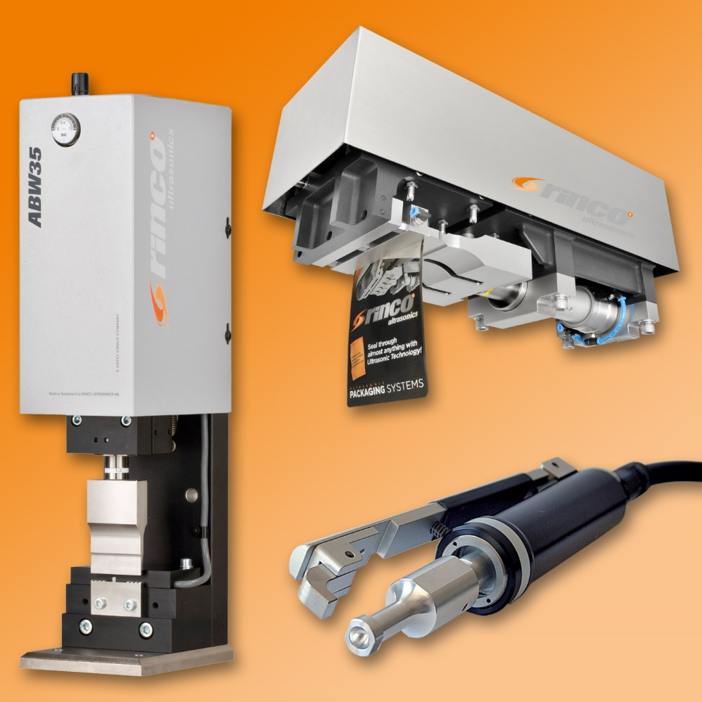
The ultrasonic welding machines from Rinco Ultrasonics showcased at this year's Interpack satisfy the needs of the packaging industry with regard to reliably sealed packaging. The spectrum ranges from the small hand device to the large sealing machine and also includes actuators for integration into automation lines and special-purpose machines.
In the photo: Blister welding device ABW35, actuator FPA 4500-T and ultrasonic hand tacker HT35. (Photo: Rinco Ultrasonics)

