Rinco Ultrasonics: 40 years as an internationally acknowledged specialist in ultrasonic welding
Romanshorn/Switzerland, November 15th 2016 – Since 40 years the Swiss company Rinco Ultrasonics AG produces innovative ultrasonic welding technology. During this time, the company has grown to become a worldwide respected specialist in this sector and a competent integration consultant for its customers. With full-range systems and components for ultrasonic welding and cutting, Rinco is a reliable partner to many companies across all branches of industry, from automotive and medical technology to textile and food processing, packaging, electrical engineering, plant and machinery construction, telecommunications, and household and leisure. Rinco also works closely with international OEM partners to find the optimum solutions for their automated applications.
From manual to digital production
Rinco manufactures ultrasonic welding and cutting machines, ultrasonic generators and customized sonotrodes, components and tools. It is also continuously working on the further development of ultrasonic technology. This family company, which was founded in 1976 in the Swiss canton of Thurgau, has now become an internationally operating supplier headquartered in Romanshorn. In the course of four exciting decades, the initial business model: "Everything from a single source" has been constantly adapted to meet the market's needs.
"Today, we see ourselves as specialists in ultrasonic welding technology," says Managing Director Serge Patamia, explaining the change from manual to digital production of sonotrodes, anvils and horns. "Formerly, we produced customer's tools manually. In the meantime, we manufacture them CNC-controlled from a CAD drawing." The CAD drawing is based on a 3D visualization of the customer's application. Rinco's ultrasonic welding generators have also completed the step from analog to digital. Alongside products for standard applications, Rinco can also offer a number of special features: "We are the only firm in the industry to offer equipment with a working frequency of 70 kHz, specially designed to meet the demands of the high-tech industry with very fine, small applications," says Patamia.
40 dynamic years
A look back over the last forty years illustrates the company's innovative strength and dynamism. The initially produced ultrasonic welding devices and welding components were followed in the early 1990s by high-performance ultrasonic food-cutting systems. Rinco was one of the first companies to deploy the ultrasonic technique in the food sector, enabling it to move into new markets. In 1997, Rinco extended its field of activity and became part of the internationally operating Crest Group. Worldwide representatives and subsidiary companies make Rinco products known around the globe.
In Switzerland in 2002, Rinco received an award as the most family-friendly company in the canton of Thurgau. This is a special milestone in the company's history. Motivated and hard-working staff, who are all treated as equals at each of the company's sites, are just as important to the management as innovative product developments and balance sheet results. Rinco formulated this corporate philosophy in an SME handbook on reconciling work with family life, and presented it to the public in 2007. The head of the Swiss Federal Department of Economic Affairs (FDEA) and Federal Councilor at that time, Doris Leuthard, expressed her sincere thanks to the company for this exemplary commitment.
In 2006, Rinco received the iF Design Award for its ultrasonic generator AGM. This is one of the most prestigious design awards in the world. The same year also saw the market launch of the Dynamic series, the first ultrasonic welding machine with a force sensor and proportional valve. Only a year later, Rinco introduced the first clean-room version of the ultrasonic welding machines of the Standard and Dynamic series. This was followed by the company's certification to ISO 9001 (2008), certification of the Dynamic 3000 ultrasonic welding machine: ISO Class 6 (2011), and the company's certification to ISO 13485 (2013). At K 2013 in Düsseldorf, Rinco presented for the first time the "Electrical Motion", an all-electrically driven ultrasonic welding machine. In 2014, the ultrasonic welding specialist was certified to ISO 14001.
The company continued to expand and, in 2014, established a subsidiary company in Malaysia and, one year later, set up its youngest European subsidiary in Spain. Today, Rinco has representatives in over 40 countries, ten of which have their own branches and operate locally around the globe. This global network allows the company to provide quick after-sales support, and thus maximum convenience for its customers. It also ensures a long, virtually maintenance-free service life for the Rinco products.
Investing in research and development
Rinco offers tailor-made solutions where high efficiency and precision, fast process speed, reproducibility and a manageable investment volume are required. This also includes laboratory trials in which the product is tested and optimum solutions evolved. Rinco deploys its many years of experience in the development of new and innovative products and offers its customers the optimum solution for the particular task. Says Managing Director, Serge Patamia: "We will continue to invest in the research and development of new products. This will enable us to continue in the future to repeatedly come up with state-of-the-art products, such as the new ultrasonic generator AGM Pro that we exhibited at K 2016 for integration into special-purpose machines and production lines."
RINCO ULTRASONICS AG (www.rincoultrasonics.com), headquartered in Romanshorn/Switzerland, has been a specialist in the design and manufacture of ultrasonic welding machines and ultrasonic cutting equipment since it was founded in 1976. RINCO products are used for the reliable welding of plastic components and for cutting foodstuffs and synthetic textiles. With its many years of expertise in the development of innovative solutions and consulting in the field of application technology, RINCO is an acknowledged and reliable partner to many companies in the automotive industry, medical technology, textile and food processing, packaging, electrical engineering, plant and machinery construction, telecommunications and household & leisure. RINCO ULTRASONICS has been a member of the internationally active CREST GROUP since 1997 and, with its own branches and representatives in over 40 countries around the globe, offers outstanding proximity to the customer.
■■■

Further information:
Martina Egger, Marketing Assistant
RINCO ULTRASONICS AG, Industriestrasse 4, CH-8590 Romanshorn 1
Phone: +41 71 46641-34, Fax: -01, email: m.egger@rincoultrasonics.com

Editorial contact and voucher copies:
Georg Sposny, Konsens PR GmbH & Co. KG,
Hans-Kudlich-Straße 25, D-64823 Groß-Umstadt – www.konsens.de
Phone: +49 6078 9363-0, Fax: -20, email: georg.sposny@konsens.de

Dear colleagues,
News releases from Rinco Ultrasonics, including text (German and English) and
photos in printable resolution are available for download at:
www.konsens.de/rinco.html

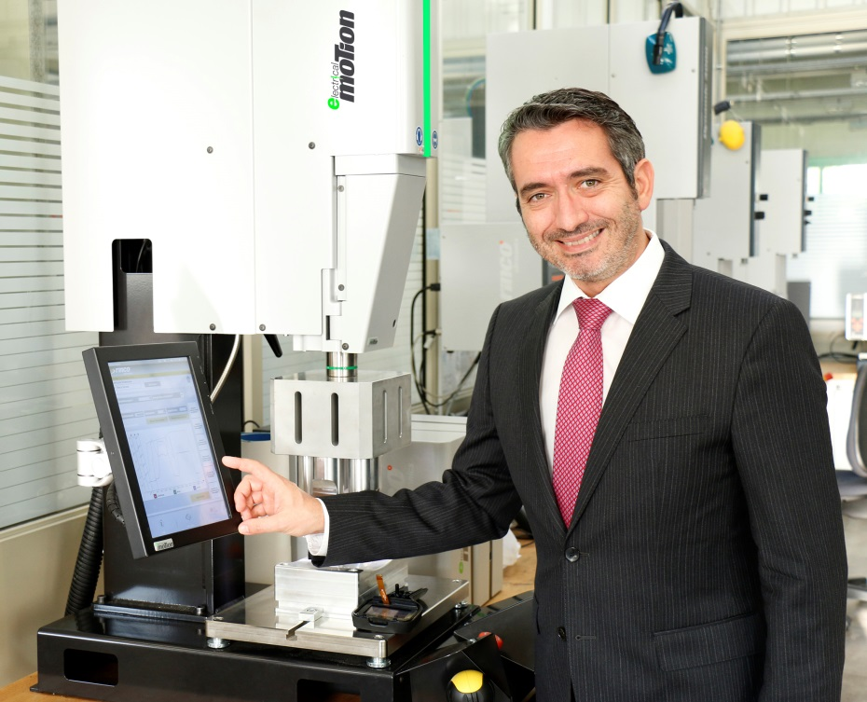
"We are the only firm in the industry to offer equipment with a working frequency of 70 kHz, specially designed to meet the demands of the high-tech industry with very fine, small applications," says Rinco's Managing Director, Serge Patamia.

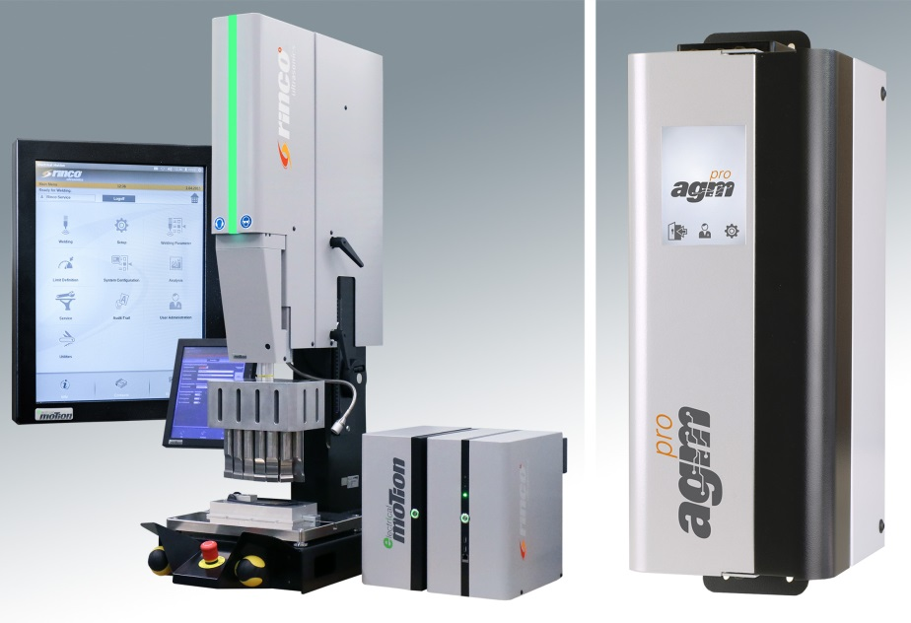
Some of the latest examples of Rinco's innovations: The electrically driven Electrical Motion, presented at K 2013 (left) and the AGM Pro ultrasonic generator showcased at this year's K, developed for integration into special-purpose machines and production lines (right).
Photos: Rinco Ultrasonics

