PRESS RELEASE
Report on the 1st International Recycling Forum for agriculturally used plastics, November 4–6, 2015, Wiesbaden:
Established collection and recycling systems play a pioneering role for the entire global industry
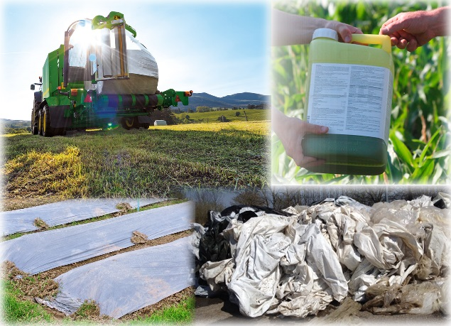 | 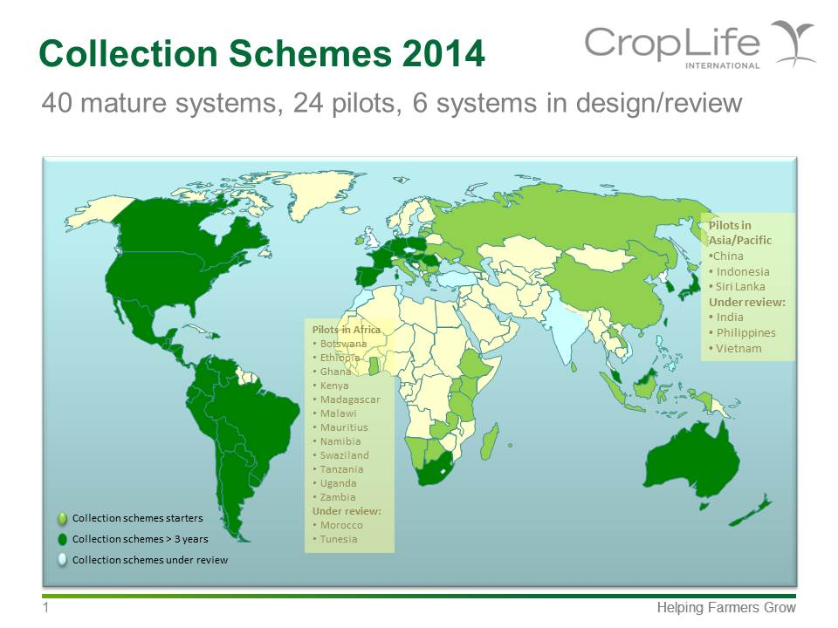
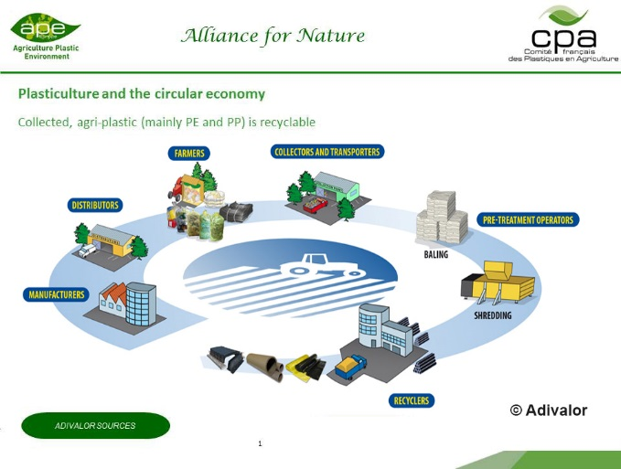 | 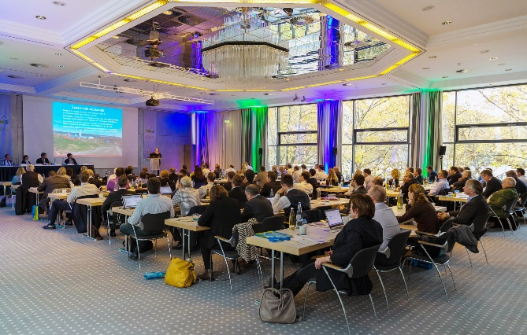
Top left: In view of continuously rising volumes, the collection and recycling of agricultural plastics is a responsible task for the entire value chain. Photo: RIGK
Top right: Collection systems for agricultural plastics are either already in place, being piloted or under review in 70 countries of the world. Source: Dr. Detlef Döhnert, BASF SE
Bottom left: The recovery of used agricultural plastics is carried out according to the same basic pattern, irrespective of the particular system. Source: Adivalor
Bottom right: Around 120 delegates from 22 countries took advantage of the two-day event to find out about the latest developments and to exchange experiences. Fig: RIGK
Wiesbaden, November 2015 – "With the increasing global demand for agriculturally used plastic products, the social obligation to take them back after use, to recycle them safely and to utilise their high recycling potential is also growing. Effective collection and recovery systems and sophisticated recycling technologies are available. They are mature and have proved themselves in practice over many years in a large number of countries. They have been shown to be both ecologically and economically efficient, and will soon be adopted by more national waste management organisations. To improve efficiency even further, however, certain questions need to be clarified, especially in relation to the pre-cleaning work done by the farmer." This was the conclusion drawn by Jan Bauer, a member of RIGK and head of the EPRO working group on the recycling of agricultural plastics, at the end of the 1st International Forum on "Agricultural Plastics – Potential for Recycling", which took place in Wiesbaden from November 4–6.
RIGK organised the symposium and the accompanying exhibition in cooperation with the European Association of Plastics Recycling & Recovery Organisations (EPRO). Some 120 industry representatives from 22 countries took advantage of the opportunity to exchange ideas for two days at international level on the possibilities that exist for the recycling of agricultural plastics. 24 speakers from research, industry, trade associations and private organisations gave presentations on the respective national initiatives, latest trends and state of the art technologies.
The first of the three subject blocks gave a fundamental overview of the type of plastics concerned and the relevant political framework conditions in the countries. Mention was also made of the respective interest groups. The second block focused on expert reports about experiences made with recovery and recycling within the framework of initiatives and market-proven operating systems in Austria, Canada, France, Germany, Ireland, Norway, Romania, Russia, Slovakia, Spain and the United States. Finally, in the third subject block, producers from France, Germany, Israel, Spain and The Netherlands reported on innovative recycling techniques.
The speakers were basically in agreement that the demand for recovery and recycling solutions internationally was high and continuing to increase. However, only the systematic collection of agricultural film, sheeting, nets, yarns, irrigation systems and packaging for crop protection products, fertilisers and hygiene products could make truly beneficial recycling possible and enable the necessary development of innovative technologies. Specifically, it was emphasised in this connection that all the countries with successful collection and recovery systems in place attain high recycling quotas – irrespective of whether these systems operate on a legal or voluntary basis. A prime example in the sense of the Extended Producer Responsibility (EPR), said Dr. Detlef Döhnert, BASF SE, is the globally pioneering role of the crop protection product industry.
Here, individual integration into the principle of shared responsibility within the overall system – from the manufacturer via the distributor and farmer to the collector and recycler – is the basis for long-term success. For example, said Bernard Le Moine, Agriculture Plastique Environnement (APE), it is indispensable that recyclers who are integrated into the relevant system can rely on continuous and consistent cooperation with the farmers who generate the waste. A key success factor is, however, also a low level of contamination of the plastic waste delivered at the collection points, an aspect that can be resolved jointly with the farmers. Having said that, the speakers were also agreed that a certain amount of contamination is unavoidable in practice.
"The collection of agriculturally used plastic films and sheeting yields a mixture of expected contaminants such as stones and sand, but also some unexpected components such as animal corpses or tyres, plus, in terms of weight, a quite small proportion of plastic," said Werner Herbold from Herbold Meckesheim. "That is why thorough cleaning of the collected material at an early stage is decisive for the success of the recycling operation. Only if the highly abrasive components are efficiently separated off can further processing make economic sense." This statement was also applicable to the collection of containers, in which full removal of residues with a potentially high hazard potential was elementary, said Angel Martinez, Acteco.
As representatives of the machinery manufacturers and recyclers convincingly stated, the required sophisticated technologies and systems for solving these problems are available and proven in practice so that, at the end of the cycle, high-quality recyclate can be made available in a well-functioning overall system for a variety of product applications. This comment was also underscored by the machine makers and recycling companies who made the journey from Europe and North America and presented their products and technological know-how at the accompanying exhibition.
Peter Sundt, General Secretary of the EPRO, summed up: "A certain proportion of the agriculturally used plastic products is packaging for which the EU Directive on packaging and packaging waste and the “principle of extended producer responsibility” apply. Corresponding recovery systems are being organised and developed by all 18 members of the EPRO, which was founded in 1997. As far as the collection and recycling are concerned, many members of the EPRO have recognised that there are a number of common features between conventional household and industry packs, agricultural packaging and further-reaching applications of plastics in agriculture. For this reason, they have made agricultural plastics a core topic on their agenda. They are calling for an exchange of the know-how within the EPRO and their members in order to release synergies and enable win-win situations for all concerned. For example, the procedure with the organisation of efficient EPR systems is an interdisciplinary core topic. Here, the experience gathered with plastic packaging can be applied to other plastic applications because the materials stem from the same producer sources, and the recyclers are also the same. Bundling existing forces to develop further well-functioning systems is therefore key for the near future. The enormous demand that exists for exchanging ideas and information is demonstrated by the success of this conference."
As a certified specialist company for trademark users (fillers, distributors, traders and importers), RIGK GmbH (www.rigk.de), founded in 1992, organises the recovery of used, empty packaging and plastics from its German customers and arranges the safe and sustainable recycling of them. This includes the company’s services for industrial and commercial packaging of non-hazardous (RIGK-SYSTEM) and hazardous products (RIGK-G-SYSTEM). Other RIGK services include RIGK-PICKUP (the free collection of empty packaging from industrial and commercial end consumers), as well as the recovery systems tailored to the agricultural sector PAMIRA® (pesticide packaging), BEIZE (seed dressing packaging), PRE® (unusable pesticides and other chemicals), as well as FOLIO & NETTI (crop forcing films, nets und yarns) and ERDE (agricultural films). In addition, the company provides advice on the development of individual recovery and recycling solutions. On an international level, RIGK is represented in Romania and Chile. The Romanian subsidiary (www.rigk.ro) also undertakes the recovery and recycling of used packaging and plastics there. RIGK Chile SpA advises the local industry in establishing their systems and complying with legal environmental and recycling constraints. The shareholders of RIGK GmbH are well-known manufacturers of plastics and packaging. RIGK GmbH has been a member of EPRO since 2006, where it established the working group for the recycling of agricultural plastic waste under the leadership of Jan Bauer.
® = registered trademark of the Industrieverbandes Agrar e.V. (IVA)

EPRO, the European Association of Plastics Recycling and Recovery Organisations
(www.epro-plasticsrecycling.org), is a pan-European partnership of specialist organisations which are in a position, today and in the future, to develop and provide efficient solutions for the sustainable handling of plastic waste. The members of EPRO are working on the optimisation of the national possibilities through international collaboration: by studying successful approaches and assessing different solutions and constraints. In the collaboration, the members of EPRO can achieve synergies which promote the recycling and the reuse of plastics. EPRO currently unites 18 organisations from 15 European countries, South Africa and Canada under a single umbrella.
Further information:  RIGK GmbH  Claudia Hoese  Marketing and Customer Care  Friedrichstr. 6, D-65185 Wiesbaden  Tel.: +49 (0) 6 11/ 30 86 00-12, Fax: -30  E-Mail: hoese@rigk.de; www.rigk.de | Editorial contact and specimen copies:  Konsens PR GmbH & Co. KG  Dr. Jörg Wolters  Hans-Kudlich-Strasse 25  D-64823 Gross-Umstadt  Tel.: +49 (0) 60 78/93 63-0, Fax: -20  E-mail: joerg.wolters@konsens.de; www.konsens.de

You can find this press release as a doc-file and
the image in a printable resolution to download at:
www.konsens.de/RIGK.html

