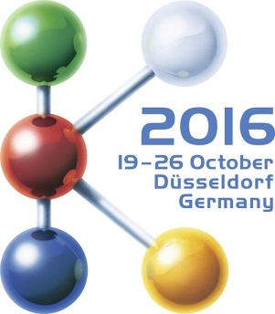  Hall 9, Stand B22 | Press Release  MTI Mischtechnik International GmbH  Katharina Nowak  Ohmstr. 8, D-32758 Detmold/Germany  Phone: +49 (5231) 914-113  Fax: +49 (5231) 914-27113  Mail: marketing@mti-mixer.de  Web: http://www.mti-mixer.de
Launching Vent tec® 2.0 as a world first:
High-performance mixer aspiration ensures constant process conditions
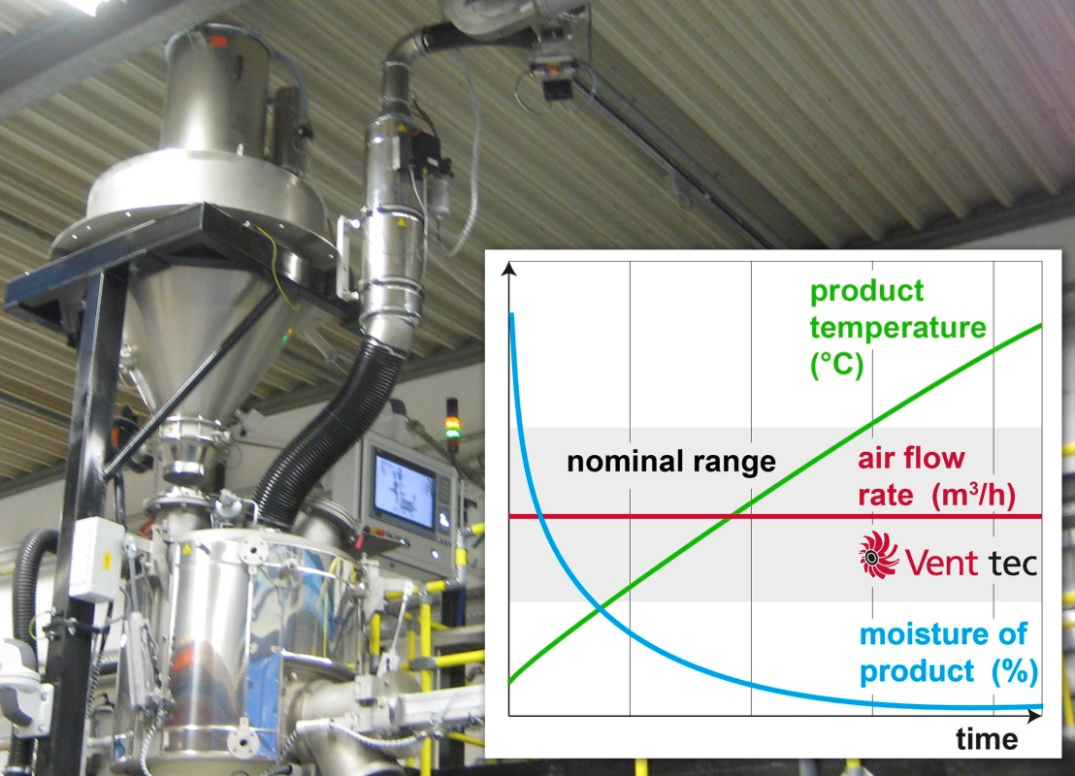
Unlike conventional systems, the new Vent tec 2.0 high-performance aspiration systems for heating/cooling mixer combinations control their own performance independently as a function of actual process parameters. They are thus key to achieving constantly high product qualities in the plastics processing and chemical industries.
Detmold/Germany, July 2016 – With the launch of Vent tec® 2.0, MTI Mischtechnik (www.mti-mixer.de) presents a new generation of its proven high-performance aspiration systems for heating/cooling mixer combinations. Unlike conventional solutions, these devices are the first ever to control their operation autonomously as a function of actual process parameters, thereby providing constant processing conditions irrespectively of changes in process and ambient conditions. Accordingly, they significantly facilitate the task of maintaining uniformly high product quality in the plastics processing and chemicals industry.
Main applications include the production of rigid and soft PVC dryblends and natural fibre compounds (WPC/NFC/PPC) as well as thermal processes where Vent tec® 2.0 devices serve to dehumidify the mixture and/or to reduce the volatiles content. The new generation aspirator systems are available in various sizes for all mixing volumes and accommodating nearly all ATEX environments and mixer designs. Thanks to their autonomous control technology, they can also be retrofitted on other manufacturers' machines.
Prevents deposits, saves time and cost
At process temperatures markedly exceeding the boiling point of water, even low humidity levels may interfere with the process. This is even more relevant for PVC recipes containing hygroscopic stabiliser systems. Without a high-performance aspiration capability, the result may often be massive deposits on the interior surfaces of heating mixers, cooling mixer walls and extruder dies, as well as in calibration devices. The potential consequences may include a diminished mixing quality, extruder problems and fluctuations in the final product. In all such situations, Vent tec® mixer aspiration technology by MTI Mischtechnik provides the necessary uniformly high dehumidification rates for constant production results. Compensating effectively for variations in raw material moisture and seasonal influences on the processing properties of the mixture, these systems provide an unvaryingly high dryblend quality with ultimate humidities ranging down to below 0.05%.
For the manufacturer, this high performance leads to compelling advantages. Thus, an almost fully dehumidified dryblend will permit a high output of downstream machinery. Little or no deposits minimise the time and cost of cleaning the mixing system and all additional equipment, while a constantly high product quality reduces scrap. Together, these three benefits can provide significant cost savings and extended maintenance intervals, thereby resulting in a clearly increased availability of the entire production line.
Closed-loop control for constant drying performance
More traditional aspirator systems would not take into account changing process parameters but instead activate/deactivate the exhaust air system as dictated by the process, with filter cleaning being performed at fixed pre-defined trigger points. This approach is typically linked with disadvantages such as diminishing air output due to progressive filter contamination, causing quality variations in the final product. MTI Mischtechnik's Vent tec® 2.0 aspiration systems, in contrast, continuously monitor all actual operating conditions via key parameters such as intake air and system air temperatures, air pressure, humidity and, with high significance, the aspiration air flow rate. Their electronic controller continuously analyses these variables and adjusts the aspiration system accordingly with due regard to the filter status, keeping aeration airflow conditions constant. In addition, the system reports incipient wear of the process filter at an early stage, thereby allowing preventive maintenance to be carried out. Thus, Vent tec® 2.0 aspirator systems are key to both constantly high drying performance and product quality.
MTI Mischtechnik International GmbH, established in 1975, is an internationally leading manufacturer of mixing and processing equipment for the plastics processing, chemical, food and pharmaceutical industries. With a staff of around 50 employees working at its headquarters site in Detmold, Germany, the company manufactures mixer systems with outstanding mixing, energy and cost efficiency. The portfolio includes vertical high-speed mixers, horizontal mixers, heating/cooling mixer combinations, universal mixers, laboratory mixers as well as tailor-made systems. With an export quota of around 80%, MTI Mischtechnik is globally aligned and, as an owner-managed family business, relies on quality that is "Made in Germany".
Editorial contact / please send voucher copies to:
Dr.-Ing. Jörg Wolters, KONSENS Public Relations GmbH & Co. KG
Hans-Kudlich-Straße 25, D-64823 Groß-Umstadt / Germany
Phone: +49 (6078) 9363-13, Fax: +49(6078) 9363-20
E-mail: mail@konsens.de, www.konsens.de
Dear Colleagues,
The text of this press release in MS-Word format, as well as the
colour photo in print-quality resolution, are available for download at:
http://www.konsens.de/mti-mischtechnik.html

