Hall 1, Stand 1-154 | MTI Mischtechnik International GmbH  Katharina Nowak  Ohmstraße 8, D-32758 Detmold  Phone: +49 (5231) 914-113  Fax: +49 (5231) 914-27113  E-Mail: marketing@mti-mixer.de  Internet: http://www.mti-mixer.de
Press Release
MTI Mischtechnik at Powtech 2016:
High-speed mixer for fast, cost-efficient working
Detmold/Germany, April 2016 – The vertical high-speed mixers of the Flex®-line series from MTI Mischtechnik are individually configurable process plants for the manually or fully automatically controlled preparation of bulk goods. Depending on the model, potential applications range from its use as a mixing unit for homogenising a wide range of raw materials with varying parameters by means of friction, to complex processes that are aimed at obtaining specific product properties. Typical fields of application include chemical and plastics processing, although mixers of this kind have also proven themselves for a variety of other specific tasks. In many cases they can shorten the process time and simultaneously attain higher product quality than with conventional processing technologies, for example in the dye industry and in the production of silica compounds. At Powtech 2016, MTI will present its Flex®-line high-speed mixers in Hall 1 on Stand 1-154 as part of its extensive portfolio of performance-optimised mixing and processing machines.
The geometrical design of the mixing tools in the vertical Flex®-line high-speed mixers can be varied over a wide range. This allows optimum adjustment of the shear forces to application-specific requirements. It is thus possible to ensure careful homogenisation even of highly sensitive educts and, for example, to carry out the granulation with very high bulk density. Spray systems for liquids, a double jacket for temperature-controlled process management and vacuum or pressure shock-resistant design of the vessel are additional features that enable coating and melting processes to be carried out with optimum reproducibility. The particularly user-friendly design of the high-speed mixer allows easy feeding, discharging and cleaning every time.
In addition to the vertical Flex®-line high-speed mixers, MTI Mischtechnik's product portfolio contains a variety of innovative mixer concepts for the plastics processing, chemical, food and pharmaceutical industries. It also includes the Uni tec® high-performance universal mixers, horizontal universal and cooling mixers and various heating/cooling mixer combinations, a highly versatile laboratory mixer as well as the Vent tec® aspiration and filter system for optimum dryblend quality and maximum reduction of moisture content.
www.mti-mixer.de
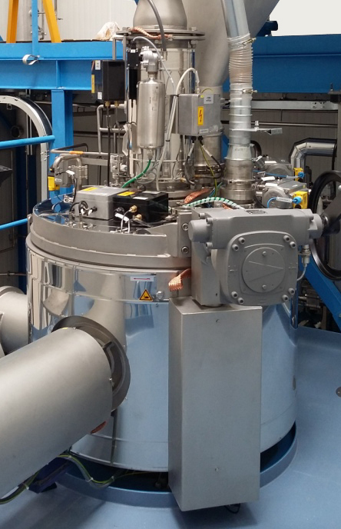
Vertical high-speed mixer of MTI's Flex®-line series; photo: © MTI Mischtechnik
MTI Mischtechnik International GmbH, established in 1975, is an internationally leading manufacturer of mixing and processing equipment for the plastics processing, chemical, food and pharmaceutical industries. With a staff of around 50 employees working at its headquarters site in Detmold, Germany, the company manufactures mixer systems with outstanding mixing, energy and cost efficiency. The portfolio includes vertical high-speed mixers, horizontal mixers, heating/cooling mixer combinations, universal mixers, laboratory mixers as well as tailor-made systems. With an export quota of around 80%, MTI Mischtechnik is globally aligned and, as an owner-managed family business, relies on quality that is "Made in Germany".

Editorial contact and please send voucher copies to:
Dr.-Ing. Jörg Wolters, KONSENS Public Relations GmbH & Co. KG
Hans-Kudlich-Straße 25, D-64823 Groß-Umstadt / Germany
Phone: +49 (6078) 9363-13, Fax: +49(6078) 9363-20
E-mail: mail@konsens.de, www.konsens.de

Dear Colleagues,
The text of this press release in MS-Word format, as well as the
colour photo in print-quality resolution, are available for download at:
http://www.konsens.de/mti-mischtechnik.html

