Hot runner nozzles for very low shot weights and extended range of cylinders
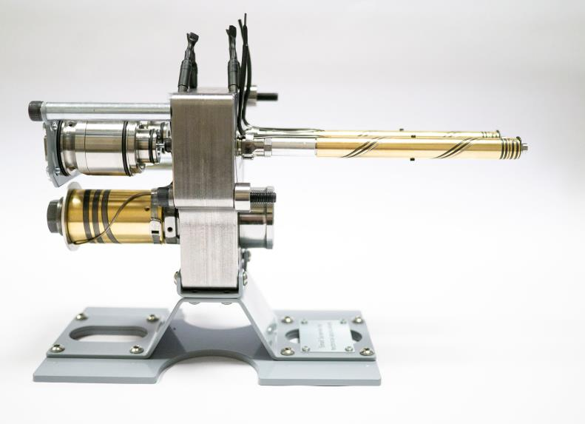
HRSflow's new SA series hot runner nozzles enable very small nozzle cut-outs for the production of molded parts with weights of less than 1 gram. © HRSflow
San Polo di Piave / Italy, May 2019 --- At Molding Expo 2019, which takes place from 21 to 24 May in Stuttgart, HRSflow will present their new small-sized SA series hot runner nozzles for injection molding small technical components with a very compact cut-out in the tool. The company will also showcase extensions of its cylinder portfolio which are particularly compact and require little installation space, including versions developed for exact needle adjustment.
With the new screwed-in hot runner nozzles of the SA series, HRSflow has expanded its range by a size, which is ranked even below the to date smallest P series. They are suitable for the injection molding of technical parts with a shot weight of about 1 g and less and for wall thicknesses below 1 mm. Their selectable gate versions open nozzle and valve gate are available with bushing through the cavity or gate on the cavity. The shape and material of the tip, the channel section and the contact surface of the end ring with the cavity are designed to have optimal thermal conditions allowing for a high flexibility in processing engineering polymers.
Their typical applications range from the automotive industry to technical components, houseware, logistics and environmental applications including productions with frequent color changes as well as the processing of glass fiber reinforced plastics or the molding of parts with particularly high-quality surfaces for subsequent painting or coating processes. The use of stack molds is possible.
The compact design of the new SA series enables a compact cut-out in the tool. At the same time, the relatively large melt channel diameter allows the processing of highly reinforced or highly viscous plastics at high flow rates. The nozzle screwed on the manifold guarantees the seal at high injection pressure without requiring accuracy in the machining of the mold.
HRSflow's extended cylinder portfolio now includes compact hydraulic cylinders, which require small cut-outs in the tool and provide an increased thermal insulation thanks to components material and optimized contact surfaces. This minimizes the heat transfer to the manifold and reduces energy consumption. Here, in addition to the basic version, a version with needle damping is also available. Further variants offer a microswitch version for the double needle end position detection as well as an adjustable version offering the possibility of compensating the position of the needle by ± 1 mm without mechanical reworking.
Finally, HRScool is HRSflow’s innovative solution for hot runner injection molding in which the water cooling of the associated actuators can be completely eliminated for the most common automotive applications. Support columns with optimized contact surfaces minimize the heat transfer from the hot tool plate to the cylinder, while a height-adjustable cover plate made of a highly thermally conductive material ensures the maximum heat dissipation from the cylinder to the cold clamping plate. By removing all elements required for active cooling, such as ducts, pipes and connections, HRScool eliminates issues associated with clogged cooling circuits.
HRSflow (www.hrsflow.com) is a division of INglass S.p.A. (www.inglass.it), headquartered in San Polo di Piave/Italy. It is specialized in the development and production of advanced and innovative hot runner systems for the injection molding industry. The group of companies has more than 1,100 employees and is present on all the major global markets. HRSflow produces hot runner systems at its European headquarters in San Polo di Piave/Italy, in Asia at its plant in Hangzhou/China and at its facility in Byron Center near Grand Rapids, MI, USA.
Contact and further information
HRSflow, Via Piave 4, 31020 San Polo di Piave (TV), Italy
Phone: +39 0422 750 111, Email: info@hrsflow.com, www.hrsflow.com
Erica Gaggiato, Communication Dept.
Phone: +39 0422 750 120, Email: erica.gaggiato@inglass.it
Press releases from HRSflow with text as well as pictures in print-ready resolution are available to download from: www.konsens.de/hrsflow.html

