HRSflow at NPE2018

Side-mounted operating cylinder for hot runner needle valve nozzles facilitates maintenance and conversion to servo-electric drive systems

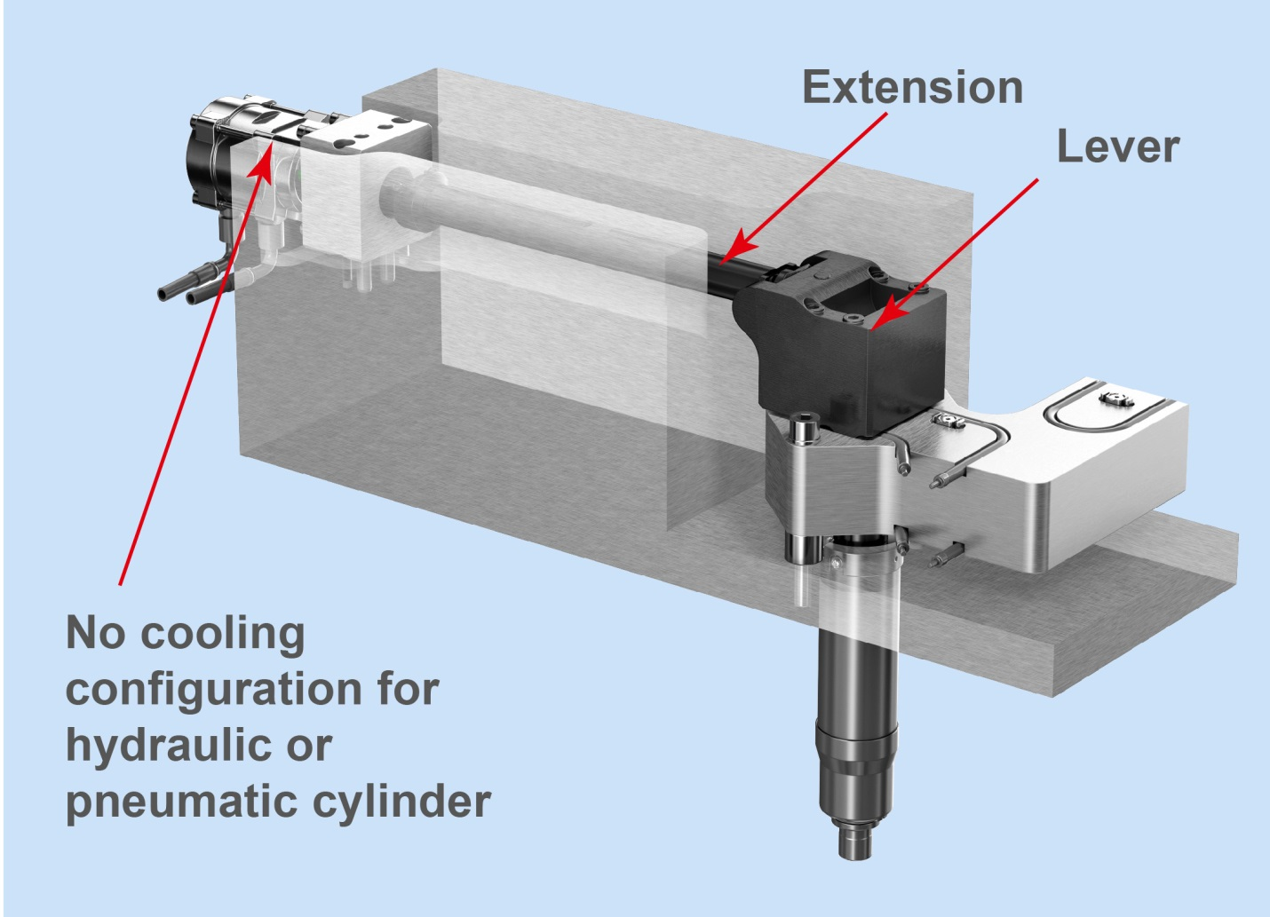
Side-mounted cylinder: The maintenance-friendly operating cylinder mounted on the side of the mold is suitable for hydraulic or pneumatic drive systems and can be easily converted to the servo-electric drive of the FLEXflow hot runner systems from HRSflow. © HRSflow
San Polo di Piave, Italy, May 7th, 2018 – With its new side-mounted cylinder, Italian hot runner specialist HRSflow has developed a constructional solution in which the hydraulically or pneumatically driven operating cylinder for the needle valve nozzle is positioned on the outside of the mold. This configuration provides time and cost benefits in repair and maintenance work, and also makes it possible to dispense with the otherwise necessary cooling facilities – without making any compromises in terms of performance and reliability.
The new development involves keeping the cylinder away from the hot runner. As a result, the components of the overall system can be accessed more easily and conveniently. Work can be carried out on the cylinder without having to disassemble the mold. Conversely, the operator can carry out maintenance work on the hot runner system by simply removing the manifolds from the levers and leaving the cylinders mounted on the mold plate.
The second big advantage of the side-mounted cylinder comes from it being placed far away from the manifold area. As a result, uncooled operation of the hydraulic or pneumatic cylinder is possible. The fact that there is no need for cooling lines or respective connections makes it possible to significantly simplify the configuration of the hot runner system and thus also of the connections in the mold.
Suitable for the innovative FLEXflow technology
The cylinder positioned on the side of the mold for operating the needle valve can be converted without much work from a hydraulic or pneumatic drive system to a servo-electric system of the FLEXflow hot runner needle valve solutions developed by HRSflow because the levers and extensions used to move the pins are the same.
The innovative FLEXflow technology is a significant step forward in sequential injection molding because, thanks to the integrated servo-electric needle drive, it offers a variety of possibilities for setting the process parameters. For example, the individual pins of a hot runner system can be controlled independently of one another with regard to their stroke, velocity and force. As a result, users can control the pressures and flow rates accurately, easily and flexibly during the entire mold-filling process and thus optimize the quality of their injection-molded parts.
The advantages attainable in this way over conventional needle valve systems make it possible not only to manufacture large Class A surfaces but also to reduce warpage. The products are also suitable for cleanroom applications thanks to the dry and clean method of working. Other benefits include the maintenance and user friendliness, and the possibility of lowering the clamping force by around 20% and the weight of the part by up to 5% - with outstandingly high reproducibility.
HRSflow (www.hrsflow.com) is a division of INglass S.p.A. (www.inglass.it), headquartered in San Polo di Piave/Italy. It is specialized in the development and production of advanced and innovative hot runner systems for the injection molding industry. The group of companies has more than 1,100 employees and is present on all the major global markets. HRSflow produces hot runner systems at its European headquarters in San Polo di Piave/Italy, in Asia at its plant in Hangzhou/China and at its facility in Byron Center near Grand Rapids, MI, USA.

Contact and further information
HRSflow, Via Piave 4, 31020 San Polo di Piave (TV), Italy
Phone: +39 0422 750 111, Email: info@hrsflow.com, www.hrsflow.com
Erica Gaggiato, Communication Dept.
Phone: +39 0422 750 120, Email: erica.gaggiato@inglass.it
Editorial contact and voucher copies
Dr.-Ing. Jörg Wolters, Konsens PR GmbH & Co. KG,
Hans-Kudlich-Straße 25, D-64823 Groß-Umstadt, Germany – www.konsens.de
Tel.: +49 (0) 60 78 / 93 63 0, Email: mail@konsens.de

Press releases from HRSflow with text (German and English) as well as pictures in print-ready resolution are available to download from: www.konsens.de/hrsflow.html

