HRSflow at K Show:
New hot runner solutions to improve the injection molding process
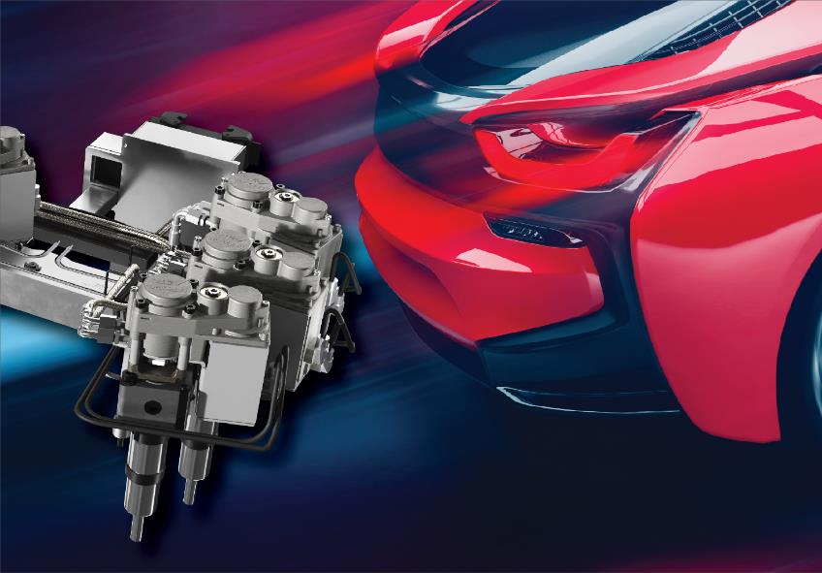
San Polo di Piave / Italy, September 2019 --- At K 2019, which takes place from 16 to 23 October in Düsseldorf, HRSflow will present at Booth D05 in Hall 1 challenging applications of their FLEXflow hot runner technology together with recent developments targeted to improve the injection molding process. These include examples for perfectly balanced Family Tools with extremely different part volumes, an extended cylinder range, the new SA series of nozzles for small shot weights, as well as HRScool, HRSflow’s innovative solution for hot runner injection molding in which water cooling of the associated actuators can be completely eliminated.
Expertise on Family Tools
Family molds for the cost and time efficient production of different parts in a single shot, have traditionally been associated with problems caused by traditional pin control methods, including poor balancing causing e. g. warpage issues. HRSflow’s hot runner technology provides a broad potential to improve the quality of the parts, to avoid cost for additional process tuning, to broaden the process window and to extend lifetime of the tool. Using servo driven valve gate technology to independently control stroke, timing and force of each individual pin, can overcome existing limitations in terms of close similarity in size, weight, wall section and volume, whilst ensuring all cavities are being filled simultaneously, preventing from overfeeding and flash formation.
- At K2019 HRSflow will showcase a family mold for the production of high quality upper and lower bumper parts in one shot. Both parts are molded using PP+14% talc and are characterized by large volume differences, i.e. 3333 cm³ and 2170 cm³ respectively. The use of the FLEXflow technology enables flawless surfaces without any flow mark and an accurate control of deflection on each component. The mold is equipped with a twenty-one-nozzle, electrically-driven valve gate hot runner system including two angled nozzles.
- A second family mold example will be the hot runner system for a one-shot production of three high-quality polypropylene parts for a car interior door module, with volumes of 560 cm³, 338 cm³ and 58 cm³ and wall thickness ranging from 2.3 mm to 3 mm. The mold is equipped with an eight-nozzle, electrically-driven valve gate hot runner system designed for sequential injection molding, allowing for a cycle time of approximately 55 s. Both hot runners are equipped with the new FLEXflow one manifold servo driven valve gate cylinders with reduced cut out, higher accuracy and enhanced repeatability.
Extended range of cylinders
At K2019 HRSflow will also showcase its recently extended portfolio of particularly compact and small cylinders which require very limited installation space. New is a series of pneumatic cylinders which can be easily installed without removing the hot runner from the mold plate. Designed for excellent thermal insulation, they do not require cooling for a wide range of polymers. Thanks to the modular design concept and a reduced number of parts they stand out through easy maintenance. The cylinders are available with or without end stroke, as damped version, also with end stroke, and with pressure sensor.
Further optimized products from HRSflow include compact hydraulic cylinders, requiring only small cut-outs in the tool. With improved material selection and design, they minimize the heat transfer from the manifold, reducing heating energy consumption. In addition to the basic design a dampened version is available. Further variants offer a microswitch for end position detection as well as an adjustable version to compensate the position of the needle by ±1 mm without mechanical reworking.
… and much more.
HRSflow will also present the SA Series, its smallest series of screwed-in hot runner nozzles for very low shot weights, with a very compact cut-out, dedicated to process small technical components and designed to have optimal thermal conditions for high flexibility in processing engineering polymers, even with high fibre loads or high viscosities.
Another highlight will be HRScool, the innovative solution for hot runner injection molding, that allows to completely eliminating water cooling for the most common automotive applications. The design minimizes the heat transfer from the hot tool plate to the cylinder, while a highly thermally conductive cover maximizes heat dissipation from the cylinder to the cold clamping plate
Live presentation at partner booths
Visitors of K2019 will be able to experience HRSflow’s hot runner technology on a couple of the company’s partners booths, including Sumitomo (SHI) Demag (Stand D22 in Hall 15), Krauss Maffei (Stand B27 in Hall 15), Wittmann Battenfeld (Stand C06 in Hall 15), ENGEL (Stand C58 in Hall 15), Yizumi (Stand C59 in Hall 14), and Arburg (Stand A13, Hall 13), all of them showing cutting-edge solutions for sophisticated molding tasks.
HRSflow (www.hrsflow.com) is a division of INglass S.p.A. (www.inglass.it), headquartered in San Polo di Piave/Italy. It is specialized in the development and production of advanced and innovative hot runner systems for the injection molding industry. The group of companies has more than 1,100 employees and is present on all the major global markets. HRSflow produces hot runner systems at its European headquarters in San Polo di Piave/Italy, in Asia at its plant in Hangzhou/China and at its facility in Byron Center near Grand Rapids, MI, USA.
Contact and further information:
HRSflow, Via Piave 4, 31020 San Polo di Piave (TV), Italy
Phone: +39 0422 750 111, Email: info@hrsflow.com, www.hrsflow.com
Luana Feletto, Communication Dept.
Phone: +39 0422 750 250, Email: luana.feletto@inglass.it
Editorial contact and please send voucher copies to:
Dr.-Ing. Jörg Wolters, Konsens PR GmbH & Co. KG,
Hans-Kudlich-Straße 25, D-64823 Groß-Umstadt, Germany – www.konsens.de
Tel.: +49 6078 9363 0, Email: mail@konsens.de
Press releases from HRSflow with text as well as pictures in print-ready resolution are available to download from: www.konsens.de/hrsflow.html

