Ettlinger at K 2019
Largest ERF continuous melt filter for ultra-high throughputs and removing difficult contaminants
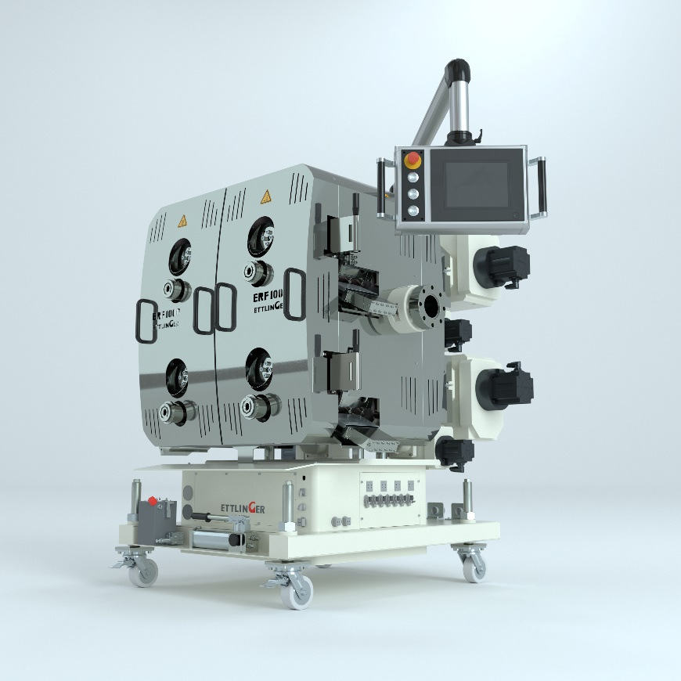
The new ERF 1000 high performance melt filter supplies high quality recycled material for sophisticated applications, even at very high throughputs of up to 10,000 kg/h.
© Ettlinger
Königsbrunn/Germany, September 2019 – Ettlinger, a member of the Maag Group, will take advantage of the upcoming K 2019 to unveil the brand new ERF 1000 high performance melt filter for very high throughputs in recycling applications for plastic materials at Stand A04 in Hall 9. The four filter drums provide a total of 6280 cm² of filtration surface – twice as much as the ERF 500, the previous top-of-the-range model – and reliably remove foreign particles from polymer feedstock containing up to 18% contaminants. Both machines share the same compact and small footprint. ERF filters are now available in four different sizes, starting with the ERF 200 for throughputs up to 800 kg/h. With a maximum of 10,000 kg/h depending on the application, the new ERF 1000 is the manufacturer’s biggest model to date.
The filter is Ettlinger’s response to the accelerating industry trend in many parts of the world toward higher throughputs on the one hand and even higher qualities on the other – a trend triggered by the rising global demand for premium quality recycled materials for sophisticated applications. The high-performance and cost-efficient ERF 1000 combines high productivity with an ability to meet ever stricter quality requirements. It is suited for virtually any kind of plastic that is relevant for recycling, including packaging plastics such as LDPE, LLDPE and HDPE, which occur in particularly large amounts. The large 6280 cm² of filtration surface along with our 60 µm (230 mesh) screen size – which is now also available for all Ettlinger filter models – enables qualities that were previously out of reach. High quality film recycling will greatly benefit from the ERF1000 capability. The ERF’s high processing reliability, coupled with a powerful control system that was designed with maximum user friendliness in mind, means that only minimal human resources are tied up.
Like all Ettlinger ERF filters, the new ERF 1000 is self-cleaning and works with a rotating, perforated drum, through which there is a continuous flow of melt from the outside to the inside. A scraper removes the contaminants that are held back on the surface and feeds them to the discharge system. As a new feature, the ERF 1000’s four filter drums can be individually replaced without disrupting production. The filter can thus run continuously and fully automatically, often over a period of several months at a time, with advantages such as ultra-low melt losses and good mixing and homogenizing of the melts. The large surface area of the drums, along with the continuous cleaning principle, makes it easier to check the process pressures and guarantees a constant pressure during operation. If they already own another ERF melt filter, customers who purchase a ERF 1000 will in the future be able to profit from compatible wearing parts such as screens, frames and scrapers, leading to simplified spare parts management.
Volker Neuber, Managing Director Ettlinger: “Legal regulations, consumer and customer requirements irrespective of the industry and rapidly increasing environmental awareness worldwide mean the demand for recycled materials that close recycling loops is growing at an above-average rate. That applies not only to technical components but also to films and containers, for instance. Efficient filters that remove even the tiniest contaminants reliably without any disruptions to the process, even at high throughputs, are vital in order to produce those recycled materials economically. Ettlinger’s new ERF 1000 does precisely that.”
Ettlinger Kunststoffmaschinen GmbH was founded in 1983 and today is a global player in the development and manufacture of high performance melt filters and injection molding machines. With its headquarters in Königsbrunn, not far from Augsburg/Germany, Ettlinger has been part of the Maag Group since 2018.
Maag is a worldwide leading manufacturer of gear pumps, pelletizing and filtration systems and also pulverizers for sophisticated applications in the synthetic, chemical, petrochemical, pharmaceutical and food industries.
Dover is a diversified global manufacturer with annual revenue of approximately $7 billion. We deliver innovative equipment and components, specialty systems, consumable supplies, software and digital solutions, and support services through three operating segments: Engineered Systems, Fluids and Refrigeration & Food Equipment. Dover combines global scale with operational agility to lead the markets we serve. Recognized for our entrepreneurial approach for over 60 years, our team of over 24,000 employees takes an ownership mindset, collaborating with customers to redefine what's possible. Headquartered in Downers Grove, Illinois, Dover trades on the New York Stock Exchange under "DOV." Additional information is available at dovercorporation.com
More information on Ettlinger
Karsten Bräunig, Manager Sales
Ettlinger Kunststoffmaschinen GmbH, Messerschmittring 49, D-86343 Königsbrunn
Phone: +49 8231 34908 -12, Fax: -28, Email: karsten.braeunig@maag.com
www.ettlinger.com

Editorial contact and specimen copies:
Dr. Jörg Wolters, Konsens PR GmbH & Co. KG
Hans-Kudlich-Strasse 25, D-64823 Gross-Umstadt – www.konsens.de
Phone: +49 (0) 60 78 / 93 63 - 0, Fax: - 20, Email: joerg.wolters@konsens.de
Ettlinger press releases with pictures in printable quality can be downloaded from: www.konsens.de/ettlinger.html

