At Wire 2016 The Chemours Company presents its broad portfolio
of Teflon™ resins for the wire & cable industry
Düsseldorf/Germany., 4 April 2016 – At Wire 2016, The Chemours Company (“Chemours”) (NYSE: CC), a global chemical company with leading market positions in titanium technologies, fluoroproducts and chemical solutions exhibits its wide range of fluoroplastics for the wire and cable industry in hall 17, stand D66. This includes further additions to the ECCtreme™ ECA family, a class of melt-processable perfluoroplastics which combines the advantageous mechanical, electrical and chemical properties of PTFE with high thermal stability. For instance, at a thickness of 0.75 mm, the material has an RTI (Relative Thermal Index) listing of 300 °C according to UL 746B. Thanks to its continuous service temperature of 300 °C, ECCtreme™ ECA thus exceeds the previous upper limit of 260 °C for conventional perfluoroplastic insulating materials.
ECCtreme™ ECA grades can be processed on conventional extrusion equipment for high-temperature fluoroplastics using standard processing conditions. Downstream heat treatment (epitaxial co-crystallisation) improves the material's thermal resistance and offers beneficial mechanical properties, such as long-term tensile modulus and improved stress cracking resistance.
The material is suitable for wire and cable insulations, which are exposed to extreme service conditions such as very high temperatures, elevated pressures and corrosive surroundings. Typical fields of application are the oil and gas industry, aerospace, energy generation, semiconductor fabrication and the automotive industry. "This development is our response to industry's challenge to offer a high-temperature, melt-processable perfluoroplastic", explains Frenk Hulsebosch, Global Product Manager Melts Fluoroplastics at Chemours Fluoropolymer Solutions.
Further products presented on the stand include Teflon™ fluoroplastic foam resins (FFR) produced using patented Airquick technology. Cables made with foamed fluoroplastic insulation have a lower signal return loss than conventional data cables, so enabling miniaturization and weight savings thanks to lower density and thinner insulation thicknesses. One current example is the new KL24 Star-Quad data cable developed for the aerospace industry by Draka Fileca, Sainte-Geneviève, France which won a DuPont Plunkett Award in 2013. At identical diameter, it is up to 25 per cent lighter than previously used quad cables and enables a reduction in aircraft fuel consumption, so reducing environmental impact.

About The Chemours Company
The Chemours Company (NYSE: CC) helps create a colorful, capable and cleaner world through the power of chemistry. Chemours is a global leader in titanium technologies, fluoroproducts and chemical solutions, providing its customers with solutions in a wide range of industries with market-defining products, application expertise and chemistry-based innovations. Chemours ingredients are found in plastics and coatings, refrigeration and air conditioning, mining and oil refining operations and general industrial manufacturing. Our flagship products include prominent brands such as Teflon™, Ti-Pure™, Krytox™, Viton™, Opteon™ and Nafion™. Chemours has approximately 8,100 employees across 35 manufacturing sites serving more than 5,000 customers in North America, Latin America, Asia-Pacific and Europe. Chemours is headquartered in Wilmington, Delaware and is listed on the NYSE under the symbol CC. For more information, please visit chemours.com or follow Chemours on Twitter at @chemours.

# # #

Chemours™ and the Chemours Logo are trademarks or registered trademarks of The Chemours Company.

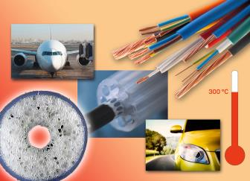
Picture: Chemours
At Wire 2016 Chemours presents its extensive offering for the wire and cable industry.
Key solution topics are highest service temperatures of up to 300 °C, miniaturization, superior data transfer, weight savings as well as patented PTFE Channel Extrusion Technology providing improved electrical properties.

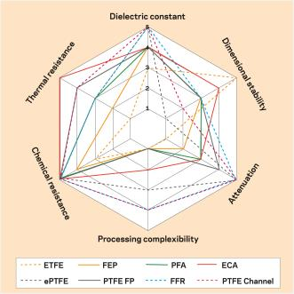
Graph: Chemours
Wire & cable property performance of various fluoroplastics and technologies.

CONTACT:
Chemours Deutschland GmbH
Horst Ulrich Reimer
Frankfurter Str. 229
D-63236 Neu-Isenburg
Phone: +49 (0)6102 / 82233-1297
E-mail: Horst-Ulrich.Reimer@chemours.com

