Press Release
BUSS at K2019:
New models extend applications for COMPEO compounders
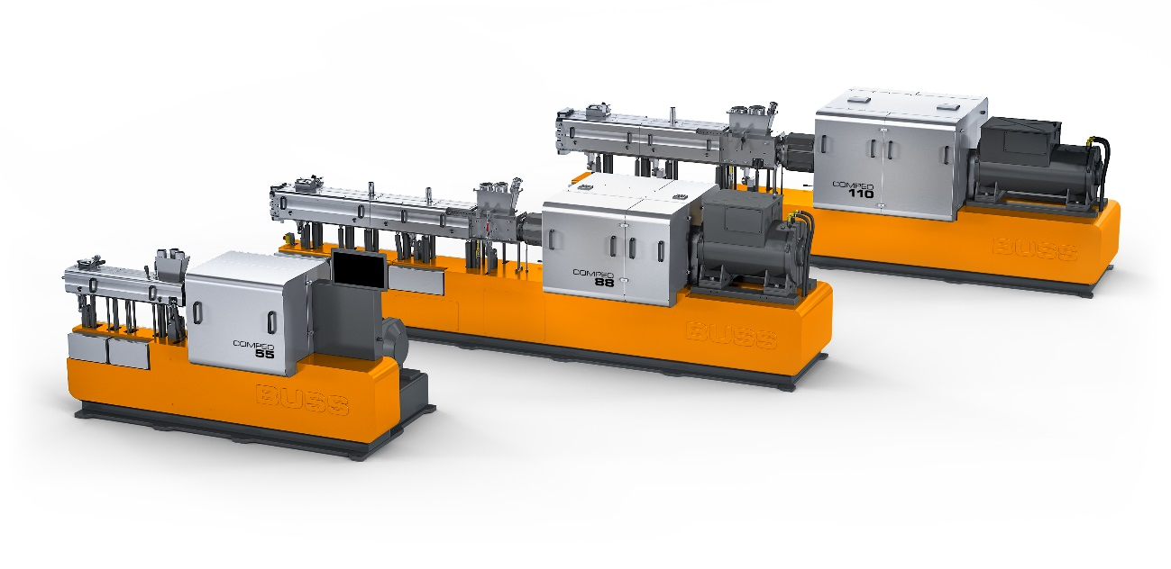
BUSS's new COMPEO 88 and 110 models will be introduced at K2019, adding higher throughput machines to the COMPEO series. © BUSS AG
Pratteln, Switzerland, September 2019. BUSS's new COMPEO 88 and COMPEO 110 kneaders for plastics and elastomers are to be introduced at K2019 in Düsseldorf, adding two higher throughput models to the COMPEO range of compounding systems. They join the smaller COMPEO 55 which was launched to the market around one year ago. All three models are available with process lengths from 13 L/D to 25 L/D, the model size indicating the screw diameter in mm. Typical throughputs for processing thermoplastics are 150-300 kg/h (COMPEO 55), 600-1200 kg/h (COMPEO 88) and 1200-2400 kg/h (COMPEO 110). This gives operators the opportunity to use a system size optimally adapted to their requirements and thus work with maximum efficiency.
In hall 16, booth A59, BUSS is presenting their current largest system, the new COMPEO 110, with a processing length of 18 L/D, including a downstream side feeder alongside their new conical twin screw discharge unit. In this configuration the system is suitable, among other things, for compounding filled and reinforced thermoplastics, including natural fiber-reinforced and bio-based plastics as well as HFFR cable compounds.
With a process length of 25 L/D, the new COMPEO 88 is optimized for compounding black or colored masterbatches and it can if required be fitted with one or two additional side feeders. The first user of such a COMPEO 88 will be a European masterbatch manufacturer who is due to take delivery of the new system from BUSS before K2019.
Specific advantages of COMPEO compounders include high-intensity mixing, high filler contents and precise temperature control. Assembled from standardized modules, they permit cost-effective configuration of specifically optimized compounding lines for a wide range of processing tasks and temperatures. These range from thermally sensitive thermosets to demanding engineering polymers with processing temperatures of up to 400°C (750°F). The great flexibility of the COMPEO series is its ability to combine conventional three- or four-flight kneading elements with new elements comprising two or six flights and to put them to use in any desired position within the process section. Combined with an increase in specific torque, this permits longer mixing zones without any additional increase in energy input. The control system with its OPC UA interface makes COMPEO completely Industry 4.0 compatible.
Visitors to the booth will also be able to discover more about COMPEO technology for various applications in the multimedia BUSS CAMPUS. This new platform will be available online after the fair and will allow registered users to download technical videos.

Further information:
Marco Senoner, BUSS AG
Hohenrainstrasse 10, CH-4133 Pratteln
Tel.: +41(0) 61/825 65 51, Fax: +41(0) 61/825 66 88
Email: marco.senoner@BUSScorp.com;

Editorial contact and voucher copies:
Dr.-Ing. Jörg Wolters, KONSENS Public Relations GmbH & Co. KG,
Hans-Kudlich-Strasse 25, D-64823 Gross-Umstadt
Tel.: +49(0) 60 78/93 63-13, Fax: +49(0) 60 78/93 63-20
Email: joerg.wolters@konsens.de; www.konsens.de
Text and images for BUSS press releases are available for download from: http://www.konsens.de/BUSS.html

