Press Release

First COMPEO compounding system for color masterbatch in operation
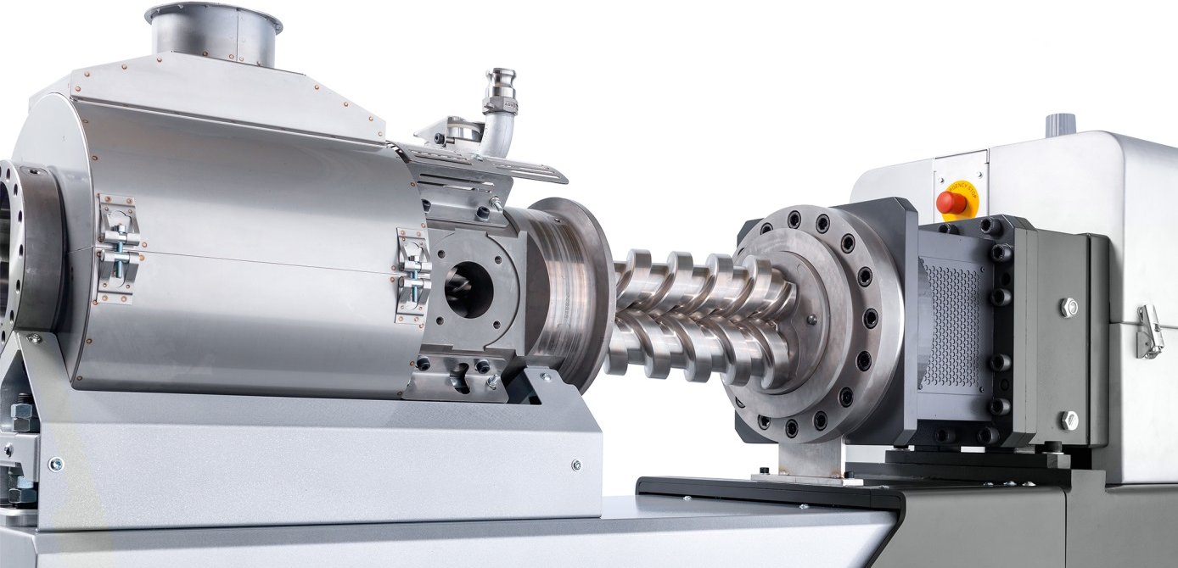
Gentle yet emphatic pressure build-up in the conical twin-screw discharge unit contributes significantly to high process consistency and uniform product quality. © Buss AG
Pratteln / Switzerland, January 2020. Only announced to the plastics industry in the run-up to K2019, a COMPEO 88 compounder from BUSS is already in industrial use. The first user is a multinational masterbatch manufacturer, which has been producing color masterbatches with this system since late October 2019. BUSS's technical center had previously optimized the screw configuration for this specific application – a service that is available to any customers with individual applications – so commissioning took just one week.
The user had selected the COMPEO 88 following extensive series of tests on different compounding systems. One major factor was the particularly efficient dispersion of the high contents of liquid components and color pigment typical of masterbatches. The liquid additives can not only be fed in together with the premix in free fall via the large-area inlet but can also be injected directly into the melt via injection pins. Another decisive factor was the uniform shear in the process section, which prevents temperature peaks and thus enables precise temperature control just above the gelling temperature of the sensitive carrier material.
The gentle yet emphatic pressure build-up in the conical twin-screw discharge unit also makes a significant contribution to achieving the stated goal of high process consistency and thus uniformly high product quality until formulation change. Due to the large number of small lots with a wide variety of formulations and colors that are typical of masterbatch production, such changes may occur very frequently. As a result, the modularity, accessibility and ease of cleaning of the COMPEO 88 were further major factors in the purchase decision.
Dr. Philip Nising, CEO of the Buss Group says: “Our customer contacted us in 2017 with his demanding compounding task. Thanks to the open and determined cooperation, a solution was quickly found that both sides found convincing and exciting. The COMPEO system proved to be the ideal basis for the combination of gentle dispersion and gentle pressure build-up in a flexible continuous process."
François Loviat, Head of Process at BUSS, adds: “By using the COMPEO 88, this manufacturer is following a growing industry trend of switching from traditional discontinuous batch processes to modern, continuous production which, thanks to optimal controllability, leads to uniform results and increases time- and cost-efficiency. Our COMPEO compounding systems, which have been tried and tested under harsh everyday production conditions, are designed to make this a smooth and seamless transition, as this present example shows. The customer’s project manager is also thrilled and, in addition to the machine's mixing properties and performance, is particularly keen to emphasize its simple, intuitive operation.”
BUSS had presented the COMPEO 88 and 110 at K2019 to join the pilot system COMPEO 55, which had already been launched on the market. All three models are available with process lengths from 13 L/D to 25 L/D, the model size indicating the screw diameter in mm. Typical throughputs for processing thermoplastics are 150-300 kg/h (COMPEO 55), 600-1200 kg/h (COMPEO 88) and 1200-2400 kg/h (COMPEO 110). With a process length of 25 L/D, the COMPEO 88 is optimized for compounding black or colored masterbatches and, if required, can be fitted with one or two additional side feeders.


Further information:
Marco Senoner, BUSS AG
Hohenrainstrasse 10, CH-4133 Pratteln
Tel.: +41(0) 61/825 65 51, Fax: +41(0) 61/825 66 88
Email: marco.senoner@BUSScorp.com;

Editorial contact and voucher copies:
Dr.-Ing. Jörg Wolters, KONSENS Public Relations GmbH & Co. KG,
Im Kühlen Grund 10, D-64823 Gross-Umstadt
Tel.: +49(0) 60 78/93 63-13, Fax: +49(0) 60 78/93 63-20
Email: joerg.wolters@konsens.de; www.konsens.de
Text and images for BUSS press releases are available for download from: http://www.konsens.de/BUSS.html

