Press Release
Updated Buss Kneader optimises cable compound production
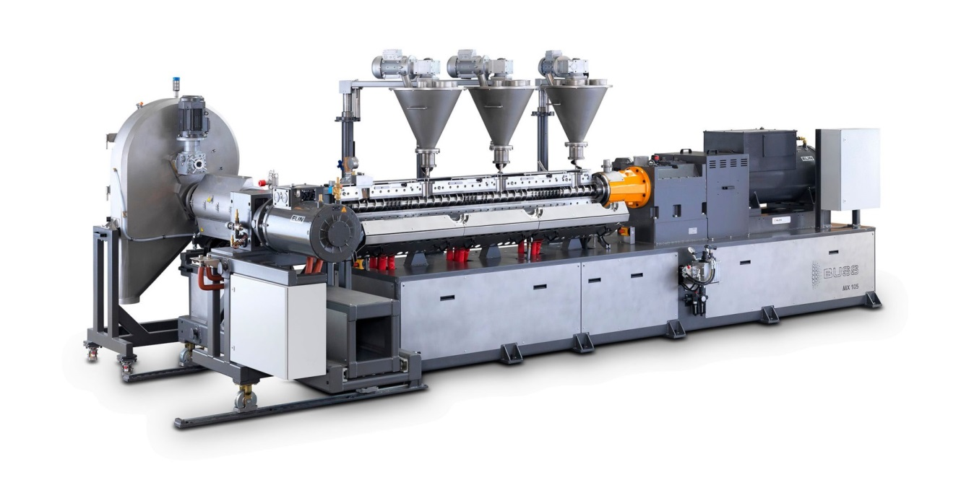
MX 105-15 F compounding line for processing Halogen-Free Flame Retardant (HFFR) cable compounds. Photo: Buss AG, Pratteln
Pratteln/Switzerland, November 2016. Buss AG from Switzerland has updated its MX 105 compounding line for processing highly filled or crosslinkable halogen-free flame retardant (HFFR) cable compounds, optimising it in many respects. Thanks to a simplified design, this system which is capable of handling throughputs of up to 1500 kg/h now has a particularly advantageous price-performance ratio without compromising on functionality, machine operability or achievable product quality. BUSS has also made the machine quieter and more energy efficient.
The MX 105 is the mid-range model of the MX series, is available with a processing length of 15 or 22 L/D and can be fitted with two or three feed hoppers. For processing semi-conductor compounds or carbon black masterbatches, the discharge extruder can be replaced by a melt pump.
The optimised toothing of the new, combined reduction/stroke gearbox offers greater efficiency together with lower noise. The electric drives of the Buss Kneader and discharge extruder are designed to operate at motor speeds which are above 70% of nominal speed while outputting at least 50% of rated torque, so ensuring they achieve efficiency of at least 90%.
The hinged process section now opens even wider to 120 degrees, providing unprecedented accessibility and further enhancing ease of maintenance and operation.
The redesigned, compact discharge extruder with a fully retractable pelletiser stands out by its greatly reduced footprint. The discharge screw is now electrically heated and air-cooled, so simplifying the line in comparison with the previous oil heating system, while simultaneously increasing safety and operational reliability. Moreover, a screen changer can now also be retrofitted.
The pelletiser's three-blade knife arm ensures excellent cutting quality at moderate speeds. The new arrangement of the knife drive improves accessibility, simplifies operation and boosts operational reliability in this area too.
The Buss MX series is fitted with SIMATIC-S7 or, with immediate availability, also with Allen Bradley control systems. User interface options include SCADA solutions with Simatic WinCC or GE-Cimplicity, while control panel options include the SIMATIC TP 2200 Comfort and the Allen Bradley Panel View series.

Further information:
Marco Senoner, Buss AG
Hohenrainstrasse 10, CH-4133 Pratteln
Tel.: +41(0) 61/825 65 51, Fax: +41(0) 61/825 66 88
Email: marco.senoner@BUSScorp.com; www.BUSScorp.com

Editorial contact and voucher copies:
Dr.-Ing. Jörg Wolters, KONSENS Public Relations GmbH & Co. KG,
Hans-Kudlich-Strasse 25, D-64823 Gross-Umstadt
Tel.: +49(0) 60 78/93 63-13, Fax: +49(0) 60 78/93 63-20
Email: joerg.wolters@konsens.de; www.konsens.de
Dear colleagues,
Please download this press release as a Word file together with the photo in print-ready resolution from: http://www.konsens.de/BUSS.html

