Best Paper Award 2018:
Buehler honors top publications on metallography
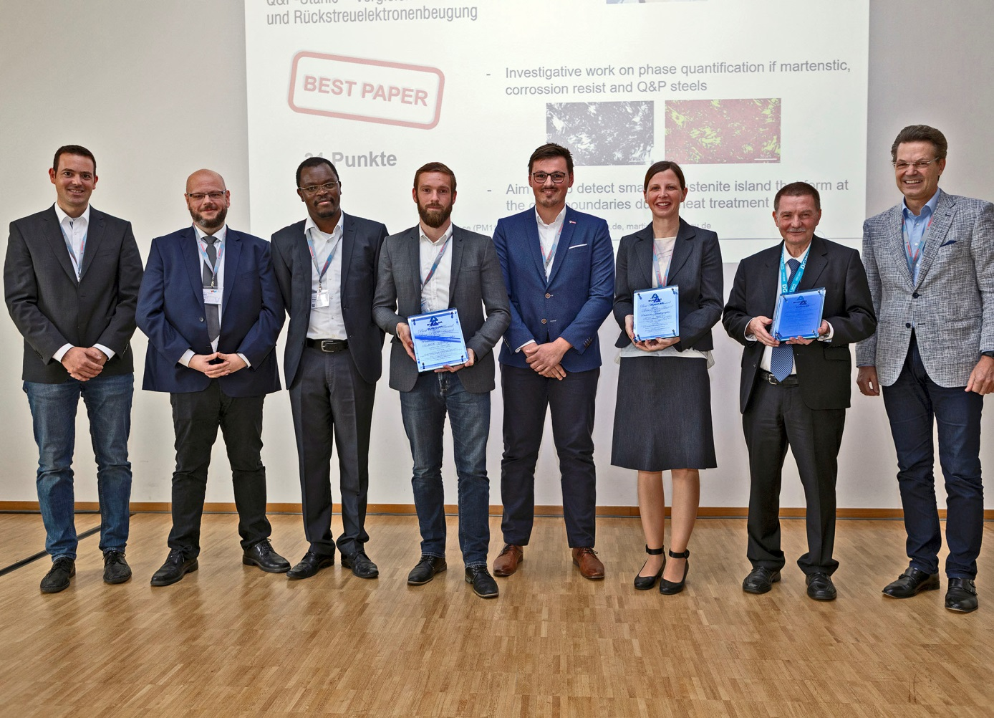
Handover of the Best Paper Awards 2018 (from left to right): Michael Engstler, Editor Praktische Metallographie, Thorsten Halle, Otto-von-Guericke-Universität Magdeburg (1st Prize), Dr. Evans Mogire, Buehler, Sebastian Dieck, Otto-von-Guericke-Universität Magdeburg (1st Prize), Martin Ecke, Otto-von-Guericke-Universität Magdeburg (1st Prize), Svea Mayer, Montanuniversität Leoben (3rd Prize), Andreas Neidel, Siemens AG Berlin (2nd Prize), Univ.-Prof. Dr.-Ing. Frank Mücklich, Editor Praktische Metallographie
© ITW Test & Measurement GmbH
Esslingen, Germany, October 2019 – On the occasion of the 53rd Metallographie-Tagung, organized by the Deutsche Gesellschaft für Materialkunde eV at the MaterialWoche in Dresden from 18 to 20 September 2019, Buehler ITW Test & Measurement presented the Best Paper Awards of 2018, recognizing the three best papers from the journal 'Practical Metallography' of the previous year. The contributions are judged by a panel of jurors made up of members of the scientific advisory board of the journal.
Place 1, combined with a check for 1,500 €, went to S. Dieck, M. Ecke, J. Frömert and T. Halle from the Otto von Guericke University Magdeburg for the contribution “Microstructural Characterization of Martensitic Q&P Steels – a Comparison of Etching Techniques and Electron Backscatter Diffraction”.
At a prize money of € 500, 2nd place went to A. Neidel, M. Giller, S. Riesenbeck and E. Wöhl, Siemens AG, with the contribution “Ageing Tests of Alloy 617 to Simulate Service Embrittlement”.
The third place winners, R. Schnitzer, C. Hofer, S. Mayer, M. Panzenböck, D. Holec and H. Clemens from the Montanuniversität Leoben received an amount of € 300 for the contribution “Multi-Scale Microstructural characterization”.
Univ.-Prof. Dr.-Ing. Frank Mücklich: "We are very pleased that the special profile of the journal 'Practical Metallography' is also visible in the high-quality contributions in which the authors share the latest findings on reproducible microstructural preparation, microscopic micrographs and quantitative microstructure evaluation with the global community. Such information is increasingly essential for the great task of the digital transformation of materials technology and its quality assurance. "
Buehler – ITW Test & Measurement GmbH, Esslingen/Germany has been a leading manufacturer of instruments, consumables and accessories for metallography and materials analysis since 1936, and also supplies a comprehensive range of hardness testers and hardness testing systems. A tight network of branch offices and dealers means our customers can depend on professional assistance and service around the world. The Buehler Solutions Centre in Esslingen and further centres of this kind in Europe and elsewhere can offer all kinds of assistance with application questions or with devising reproducible preparation procedures.
Buehler is part of the Test and Measurement Segment of the US company Illinois Tool Works (ITW) with some 100 decentralized business units in 52 countries and around 51,000 employees
For further information about products and services available from Buehler ITW Test & Measurement please visit https://www.buehler.com
Editorial contact and voucher copies:
Dr.-Ing. Jörg Wolters, Konsens PR GmbH & Co. KG,
Hans-Kudlich-Straße 25, D-64823 Groß-Umstadt – www.konsens.de
Phone: +49 (0) 60 78 / 93 63 - 0, Fax: - 20, E-Mail: mail@konsens.de
Dear colleagues, Press releases from Buehler including text and pictures in printable resolution can be downloaded from www.konsens.de/buehler.html

