Highly Efficient Cutters Reduce Time Required For Sample Sectioning in Quality Control
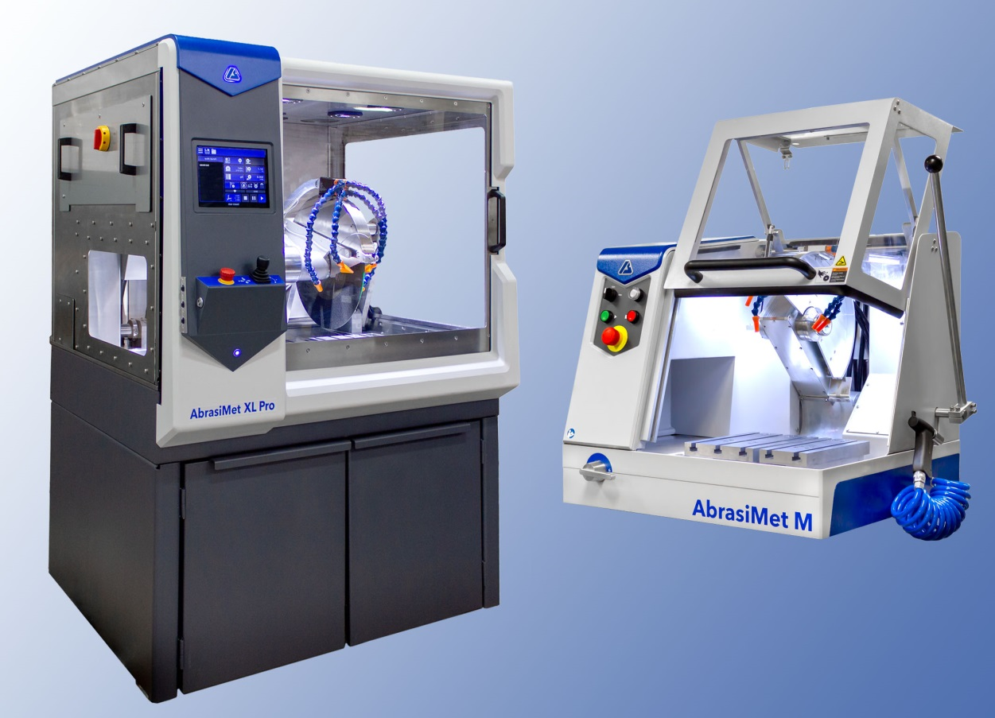
The floor-standing AbrasiMet™ XL Pro (left) and the bench-top AbrasiMet M are two new robust cutting machines from Buehler, designed to reduce sectioning time in harsh industrial quality control environments. © Buehler
Esslingen/Germany, July 2019 – With its new AbrasiMet™ XL Pro and AbrasiMet M cutters, Buehler, a leading manufacturer of instruments, consumables and accessories for metallography and materials analysis, is introducing two new sectioning machines designed for time-saving and therefore cost-efficient sectioning of samples with outstanding, high-quality sectioning results.
AbrasiMet™ XL Pro is a durable, floor-standing automatic cutting machine providing high performance in harsh industrial environments and capable of handling sample diameters up to 178 mm [7"] using chop, linear feed, and planar cutting modes. The system accommodates blade diameters ranging from 356 mm to 457 mm [14“ to 18“]. Its large cutting chamber and powerful 10 kW motor ensures repeatable sectioning with consistently high quality, even when dealing with very hard materials and/or large samples. An intuitive touchscreen interface allows users to start the section process with ease and to create and save multiple sectioning programs quickly for later access. Further features contributing to the cutter's superior efficiency are toolless blade replacement process and a rapid setup for a cut with the help of a multi-function joystick, an alignment laser and a bright lit cutting chamber. Machine is equipped with a filtration screen to remove swarf from the coolant, and a double-chamber recirculating tank that facilitates efficient cleaning.
AbrasiMet M is a manually operated bench-top cutter designed for highly consistent cuts and high sample throughput, and, like AbrasiMet™ XL Pro, holds a leading position in its device class in terms of efficiency and power. The compact and sturdy cutter utilizes 254 mm [10“] or 305 mm [12“] diameter blades. A time-saving dual-blade feature enables two parallel cuts to be performed in one operation. The sliding door allows easy access to the large cutting chamber to quickly and precisely position samples for cutting. A powerful 4 kW motor and ergonomic cutting arm, whose length and angle can be adjusted to suit the individual user, provide for a smooth and efficient cutting motion. As in the case of the AbrasiMet XL Pro, no tools are required to change abrasive blades.
Sarah Beranek, Global Director of Innovation at Buehler, comments: "In today's industrial environment, high throughput in industrial quality control labs is key to improving efficiency in production. Designed for high-use environments, the durable AbrasiMet cutters contribute essentially towards achieving this goal, by accelerating the provision of high-quality samples."

Buehler – ITW Test & Measurement GmbH, Esslingen/Germany has been a leading manufacturer of instruments, consumables and accessories for metallography and materials analysis since 1936, and also supplies a comprehensive range of hardness testers and hardness testing systems. A tight network of branch offices and dealers means our customers can depend on professional assistance and service around the world. The Buehler Solutions Centre in Esslingen and further centres of this kind in Europe and elsewhere can offer all kinds of assistance with application questions or with devising reproducible preparation procedures.
Buehler is part of the Test and Measurement Segment of the US company Illinois Tool Works (ITW) with some 100 decentralized business units in 52 countries and around 51,000 employees
For further information about products and services available from Buehler ITW Test & Measurement please visit https://www.buehler.com
Editorial contact and voucher copies:
Dr.-Ing. Jörg Wolters, Konsens PR GmbH & Co. KG,
Hans-Kudlich-Straße 25, D-64823 Groß-Umstadt – www.konsens.de
Tel.: +49 (0) 60 78 / 93 63 - 0, Fax: - 20, E-Mail: mail@konsens.de
Dear colleagues, Press releases from Buehler including text and pictures in printable resolution can be downloaded from www.konsens.de/buehler.html

