Buehler presents innovations and enhancements at Control 2019:
Wilson Universal Hardness Testers and AutoMet Grinder-Polishers - Ideal for High-Throughput Environments
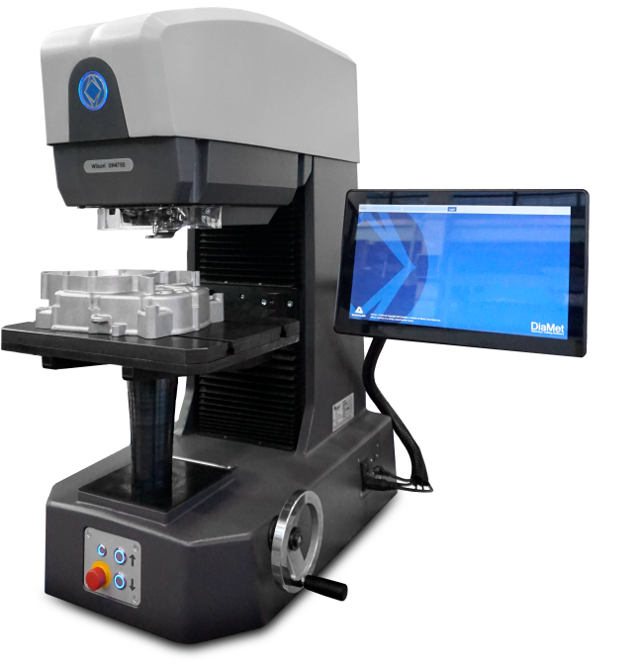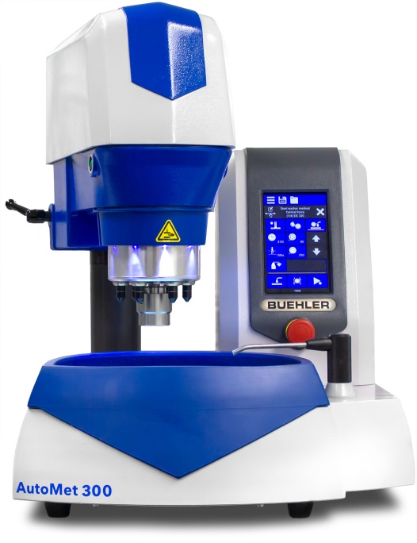
Robust Wilson® UH4000 universal hardness testers (left) and AutoMet semi-automatic grinder-polishers (right) allow for fast testing cycles and are therefore ideal for processing high sample volumes ©Buehler
Esslingen, Germany, March 2019 – At Control 2019 to be held from May 7 - 10 in Stuttgart/ Germany, Buehler ITW Test and Measurement, a leading manufacturer of equipment, consumables and accessories for metallography and materials analysis, will be showcasing at its Booth No. 5112 in Hall 5 its new, exceptionally robust Wilson® UH4000 universal hardness testers as well as the recently launched AutoMet grinder-polishers. Both products are capable of handling high sample volumes and can therefore contribute significantly towards increasing productivity and reducing costs.
Robust, automated universal hardness testers for fast testing cycles
Wilson® UH4000 universal hardness testers feature a rugged cast steel frame, provide outstanding durability and are designed specifically for harsh environments. They enable accurate hardness measurements to Rockwell, Vickers, Knoop and Brinell even in the toughest environments. Hardness scales range from 0.5 to 250 kgf in the case of the UH4250 model and from 3 to 750 kgf in the case of the UH4750 model.
A new 8-position turret designed to hold the desired combinations of indenters and objectives contributes significantly towards speeding up testing cycles in batch testing. The operator can test to a variety of test methods without the need for manual indenter/objective changes. A sturdy turret cover protects the highly accurate measurement system and turret assembly against external influences and collisions, e.g. with test pieces. The integrated DiaMet® software is intuitive to operate and makes testing easy, repeatable and automatic.
The large T-slot stage offers a clamping surface of 300mm x 400mm and high weight capacity, thus enabling testing of heavy and big parts. The new Wilson® UH4000 hardness testers are therefore flexible tools suited to a variety of tasks in quality control and process-related quality assurance, in laboratories and directly on the shop floor, for large or small components in the automotive sector and in metal production, for hardness measurements on large, flat or cylindrical castings or forgings, steels, heat treated materials, cemented carbides, ceramics, plastics and composite materials.
Semi-automatic, advanced programming of methods on grinder-polishers
The AutoMet 250 Pro and 300 Pro are semi-automatic grinder-polishers from Buehler designed specifically for customers who need to process high sample volumes in demanding environments. One of the outstanding features making this possible is the unit's intuitive touch screen interface. Advanced programming features such as method storage and z-axis controlled material removal allow for consistent results regardless of operator. The AutoMet 250 Grinder-Polisher (without the designation ‘Pro’) offers push-button controls and digital readouts. AutoMet 250 and 250 Pro are designed for 203mm or 254mm diameter platens and sample diameters up to 40 mm, whereas the AutoMet 300 Pro accommodates 254mm or 305mm platens and sample diameters up to 50 mm.
A new "Rinse and Spin" feature cleans polishing surfaces and platens at the press of a button. Further advanced features such as a retractable water hose, 360-degree bowl rinse and bowl liners save time and effort in daily operation. The Burst dispensing system, which can optionally be integrated into the system or used as a separate module, optimizes abrasive usage to save on consumables spend. Buehler also offers a complete line of compatible accessories, including splash guard, recirculation tank, and disposable bowl liners, along with consumables such as silicon carbide and diamond grinding discs, polishing cloths, diamond suspensions and pastes.
A broad portfolio of products for metallography and material analysis.
In addition to the new Wilson® UH4000 and AutoMet systems, Buehler ITW Test & Measurement will be presenting a number of other products for grinding, polishing, sectioning and mounting of samples at Control 2019, illustrating the breadth of the company's portfolio, which covers applications ranging from fundamental research to automated, process-related quality assurance. Buehler's offering includes sectioning and precision-sectioning machines, mounting systems including the associated epoxy and acrylic mounting systems, grinding and polishing machines as well as Rockwell, Vickers/Knoop, Brinell and universal hardness testers, all of which can be optimized for specific application requirements.
Buehler – ITW Test & Measurement GmbH, Esslingen/Germany has been a leading manufacturer of instruments, consumables and accessories for metallography and materials analysis since 1936, and also supplies a comprehensive range of hardness testers and hardness testing systems. A tight network of branch offices and dealers means our customers can depend on professional assistance and service around the world. The Buehler Solutions Center in Esslingen and further centers of this kind in Europe and elsewhere can offer all kinds of assistance with application questions or with devising reproducible preparation procedures.
Buehler is part of the Test and Measurement Segment of the US company Illinois Tool Works (ITW) a Fortune 200 company, with some 100 decentralized business units in 52 countries and around 51,000 employees
For further information about products and services available from Buehler ITW Test & Measurement GmbH please visit https://www.buehler-met.de/
Editorial contact and voucher copies:
Dr.-Ing. Jörg Wolters, Konsens PR GmbH & Co. KG,
Hans-Kudlich-Straße 25, D-64823 Groß-Umstadt – www.konsens.de
Tel.: +49 (0) 60 78 / 93 63 - 0, Fax: - 20, E-Mail: mail@konsens.de
Dear colleagues, Press releases from Buehler including text and pictures in printable resolution can be downloaded from www.konsens.de/buehler.html

