New Buehler Metallographic Laboratory on the campus of the University of Warwick/UK
Collaboration with Warwick Manufacturing Group Yields Synergy Effects
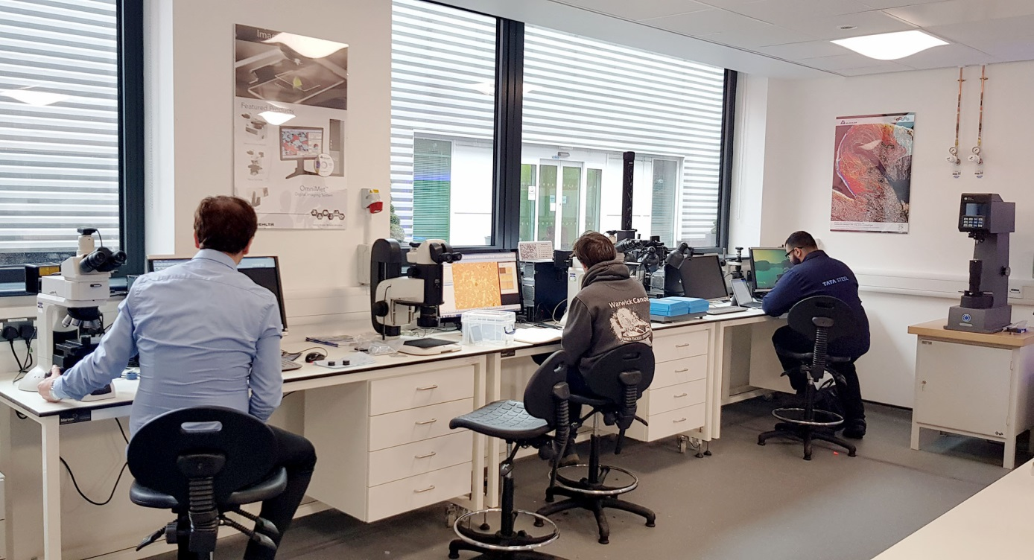
The recently opened Solutions Centre on the campus of the University of Warwick/UK is equipped with the latest systems for sample preparation and material characterisation. © Buehler
Esslingen/Germany, May 2019 – Buehler ITW Test & Measurement, a leading manufacturer of instruments, consumables and accessories for metallography and materials analysis, has opened a new European Solutions Centre in a collaborative venture with Warwick Manufacturing Group (WMG) with over 600 staff and a strong relation with over 1000 global companies, offering support to over 1800 SMEs through dedicated programmes. Part of WMG's Materials Engineering Centre at the University of Warwick campus, Buehler’s new Solutions Centre aims to support academic und industrial research on various technologies ranging from additive manufacturing, energy storage, machining and processing of metallic and composite materials to joining technologies.
The new laboratory is equipped with latest metallographic sample preparation equipment, including several abrasive and precision sectioning machines, high-end grinder-polishers and a spectral analysis system for chemical characterisation of materials. Available equipment also includes Buehler's latest hardness testers in varying degrees of automation and testing capabilities, and Nikon optical microscopes interfaced with Buehler's own image analysis software for ideal metallographic analysis.
Dr. Evans Mogire, European Technical and Laboratory Manager at Buehler, comments: "The new Solutions Centre allows us to better address complex customer applications and/or technical requests relating to metallography and provides exceptional facilities for conducting and hosting seminars in the metallographic sector. The collaboration with WMG is a win-win relationship, offering both resident material scientists and Buehler access to latest characterization technologies for metallic, polymer, ceramic and composite materials."
Paul Johnson, Technical Services Manager at WMG, adds: "This well-equipped microscopy, metallographic and materials preparation laboratory provides a valuable resource for the entire group. It offers us the opportunity to work side by side with a leading developer, producer and supplier providing us with leading-edge, perfectly maintained metallographic preparation and characterisation equipment, whilst Buehler can benefit by working with the very latest materials that we are developing and gain valuable insights for the further development of its product range."

Buehler – ITW Test & Measurement GmbH, Esslingen/Germany has been a leading manufacturer of instruments, consumables and accessories for metallography and materials analysis since 1936, and also supplies a comprehensive range of hardness testers and hardness testing systems. A tight network of branch offices and dealers means our customers can depend on professional assistance and service around the world. The Buehler Solutions Centre in Esslingen and further centres of this kind in Europe and elsewhere can offer all kinds of assistance with application questions or with devising reproducible preparation procedures.
Buehler is part of the Test and Measurement Segment of the US company Illinois Tool Works (ITW) with some 100 decentralized business units in 52 countries and around 51,000 employees
For further information about products and services available from Buehler ITW Test & Measurement please visit https://www.buehler.com
Editorial contact and voucher copies:
Dr.-Ing. Jörg Wolters, Konsens PR GmbH & Co. KG,
Hans-Kudlich-Straße 25, D-64823 Groß-Umstadt – www.konsens.de
Tel.: +49 (0) 60 78 / 93 63 - 0, Fax: - 20, E-Mail: mail@konsens.de
Dear colleagues, Press releases from Buehler including text and pictures in printable resolution can be downloaded from www.konsens.de/buehler.html

