New Polishing Guide for Metallographic Sample Preparation
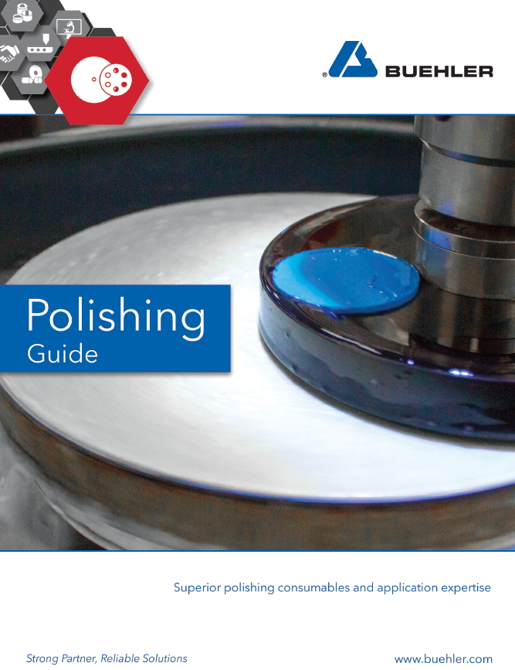
Esslingen/Germany, December 2018 – A new Polishing Guide published by Buehler offers a wealth of application and process information for metallurgical laboratory technicians. The brochure outlines optimum polishing procedures and explains how the selection of the right consumables can be a critical factor, determining whether you can start sample analysis directly or have to start again from scratch with a new sample.
In addition, the Polishing Guide contains guidance on the selection of the most appropriate polishing cloth and best suited abrasive. It provides solutions for a number of common problems, answers to frequently asked questions and recommended methods for polishing a variety of materials including electronic components, aluminum, nickel, titanium, copper, composite materials, thermal spray coatings and steels. In addition, the guide offers expert recommendations for polishing all sorts of materials using fine, medium and coarse polishing cloths.
In this context the new Polishing Guide introduces Buehler's new, durable magnetic-backed polishing cloths, which combine original Buehler polishing cloths with a stiff magnetic liner. Facilitating the removal of worn cloths, thy help saving time and enhancing efficiency.
Buehler – ITW Test & Measurement GmbH, Esslingen/Germany, since 1936 has been a leading manufacturer of instruments, consumables and accessories for metallography and materials analysis and also supplies a comprehensive range of hardness testers and hardness testing systems. A tight network of branch offices and dealers means our customers can depend on professional assistance and service around the world. The Buehler Solutions Center in Esslingen and further centers of this kind in Europe and elsewhere can offer all kinds of assistance with application questions or with devising reproducible preparation procedures.
Buehler is part of the Test and Measurement Segment of the US company Illinois Tool Works (ITW) with some 100 decentralized business units in 52 countries and around 51,000 employees.
Editorial contact and voucher copies:
Dr.-Ing. Jörg Wolters, Konsens PR GmbH & Co. KG,
Hans-Kudlich-Straße 25, D-64823 Groß-Umstadt – www.konsens.de
Tel.: +49 (0) 60 78 / 93 63 - 0, Fax: - 20, Email: mail@konsens.de
Dear colleagues, Press releases from Buehler including text and pictures in printable resolution can be downloaded from: www.konsens.de/buehler.html: www.konsens.de/buehler.html

