Buehler at Control 2019:
Mosaic Diamond Grinding Discs provide high material removal rate for samples made from steel, hard alloys and other materials
A time-saver for production-related quality control
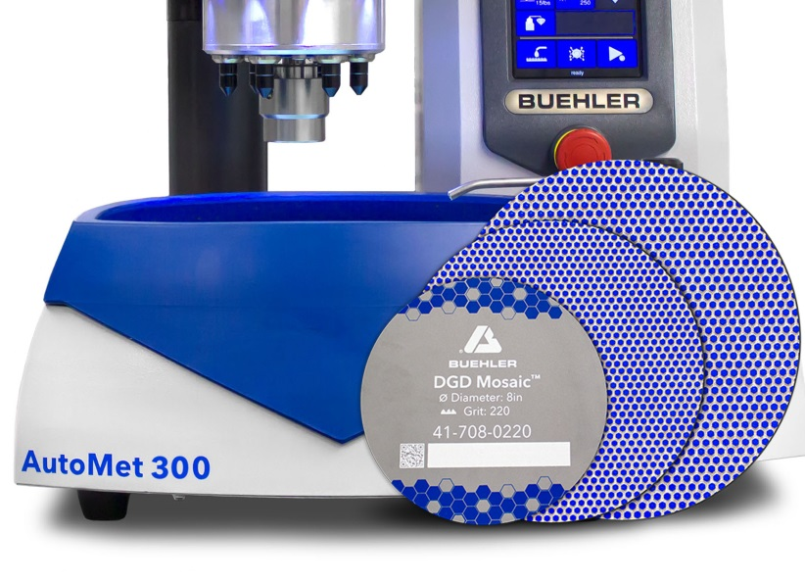 | With their high material removal rate, Buehler's new Mosaic diamond grinding discs are ideal for production-related environments and laboratories where speed and consistency are required.  © Buehler
Esslingen/Germany, May 2019 – At Control 2019, Buehler ITW Test & Measurement, a leading manufacturer of instruments, consumables and accessories for metallography and materials analysis, will be presenting its new Mosaic Diamond Grinding Discs (DGD). The fifth line of DGDs in Buehler's grinding consumable offering, Mosaic grinding discs are designed to provide high material removal rates in sample preparation and are especially suited for demanding laboratories working with medium to hard alloys, and materials that are difficult to grind.
The new Mosaic diamond grinding discs are available with a magnetic backing and come in 8”, 10” or 12” disc diameters and in 120, 220, 320, 400 and 1000 grit sizes. Typical applications include the efficient grinding of steel, sintered carbides, thermal spray coatings, and other hard materials. Beyond the high material removal rate, users will benefit in all these areas from highly consistent results, labor savings and extended lifetime, all of which contribute towards reducing the running cost of consumables.
Optimum results can be achieved in combination with the powerful grinder-polishers from Buehler's EcoMet and AutoMet series, which are designed for demanding applications in production quality control. The new Mosaic Diamond Grinding Discs significantly reduce the time required for sample preparation in many industries. In the automotive sector, for example, Mosaic DGDs are used to grind hard and heat-treated steel and other alloys; in the aerospace sector, to grind superalloys and thermal spray coatings; or in in tool making to grind samples made from cemented carbide.
Diamond grinding discs for any application
Buehler's new DGD Mosaic grinding discs with their high material removal rate are particularly suited to hard to grind materials and rapid removal of sectioning damage.
DGD Color diamond grinding discs have a moderate removal rate for enhanced surface quality and can be used with the widest range of applications, including soft and ductile materials.
DGD Terra diamond grinding discs provide a moderate removal rate and excellent flatness for superior surface quality and are ideal for very hard and brittle materials such as ceramics and glass.
DGD Ultra diamond grinding discs have a moderate removal rate and are good for samples that combine both hard and soft materials and where flatness is critical.
All diamond grinding discs from the DGD range are available either directly from Buehler or through a global distributor. Product specifications, options and ordering information are available at https://www.buehler.com/diamond-grinding-discs.php.
A full portfolio of equipment on show at Control 2019
To complement its extended range of diamond grinding discs, Buehler will be showcasing at Control 2019, to be held from 7 - 10 May in Stuttgart/Germany (Hall 5, Booth 5112), its recently launched, robust, programmable new AutoMet 300 Pro Grinder-Polishers, capable of handling high sample throughput with maximum precision, and thus contributing significantly towards increasing productivity and cost efficiency.
Further exhibits featured by Buehler will be its new Wilson® UH4000 Universal Hardness Testers along with a number of other products for grinding, polishing, sectioning and mounting of samples, illustrating the breadth of the company's portfolio, which covers applications ranging from fundamental research to automated, process-related quality assurance. Buehler's offering includes sectioning and precision-sectioning machines, mounting systems including the associated epoxy and acrylic mounting systems, grinding and polishing machines as well as Rockwell, Vickers/Knoop, Brinell and universal hardness testers, all of which can be tailored to individual customer requirements.
Buehler – ITW Test & Measurement GmbH, Esslingen/Germany has been a leading manufacturer of instruments, consumables and accessories for metallography and materials analysis since 1936, and also supplies a comprehensive range of hardness testers and hardness testing systems. A tight network of branch offices and dealers means our customers can depend on professional assistance and service around the world. The Buehler Solutions Center in Esslingen and further centers of this kind in Europe and elsewhere can offer all kinds of assistance with application questions or with devising reproducible preparation procedures.
Buehler is part of the Test and Measurement Segment of the US company Illinois Tool Works (ITW) a Fortune 200 company, with some 100 decentralized business units in 52 countries and around 51,000 employees
For further information about products and services available from Buehler ITW Test & Measurement please visit https://www.buehler.com
Editorial contact and voucher copies:
Dr.-Ing. Jörg Wolters, Konsens PR GmbH & Co. KG,
Hans-Kudlich-Straße 25, D-64823 Groß-Umstadt – www.konsens.de
Tel.: +49 (0) 60 78 / 93 63 - 0, Fax: - 20, E-Mail: mail@konsens.de
Dear colleagues, Press releases from Buehler including text and pictures in printable resolution can be downloaded from www.konsens.de/buehler.html

